ANNUAL REPORT (2021-22)
DEPARTMENT OF HISTORY

- Sir Syed Ahmad Khan Memorial lecture – 03-11-2021- Wednesday

Sir Syed college Taliparamba conducted sir Syed Ahmed Khan memorial lecture organised by department of history on 3rd November 2021, Wednesday. The program inaugurated by former education minister of Kerala, Janab. P.K Abdu Rabb. Dr. Khader Mangad, former vice chancellor of Kannur University and academician was the chief guest, who made sir Syed Ahmad Khan memorial lecture. The program scheduled at 10:30 a.m. at college Auditorium and participated by teachers, non teaching staffs, and students community of sir Syed College.
Hydarali A, head of the department of history delivered welcome address and the program was presided over by Dr. Ismail olayikkara, principal of sir Syed College. The program was felicitated by Janab. Mahmood Allamkulam (General secretary of CDMEA) Dr. Tajo Abraham (IQAC Coordinator), Purushothaman T V (Representative of Teachers community), Abdul Sathar KP (representative of non teaching staff) and Dr. Fazal E (staff association secretary) . Thwahir PH, Assistant Professor of History delivered Vote of Thanks. Dr. Khader Mangad distributed gifts to Department students, who were admitted to various universities for post graduation studies in history.

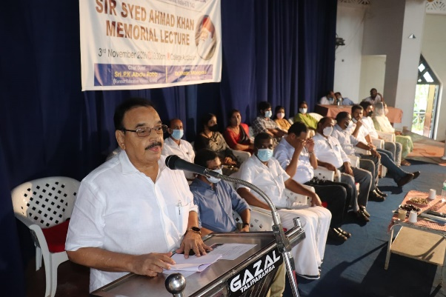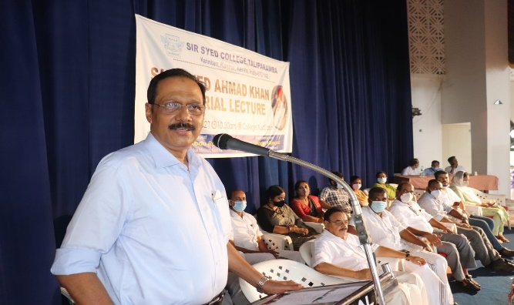

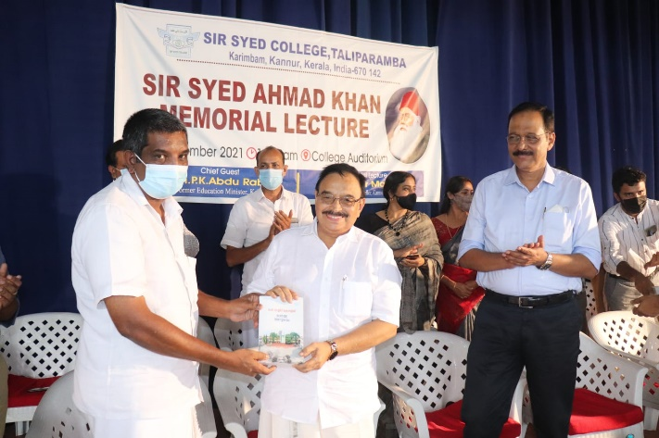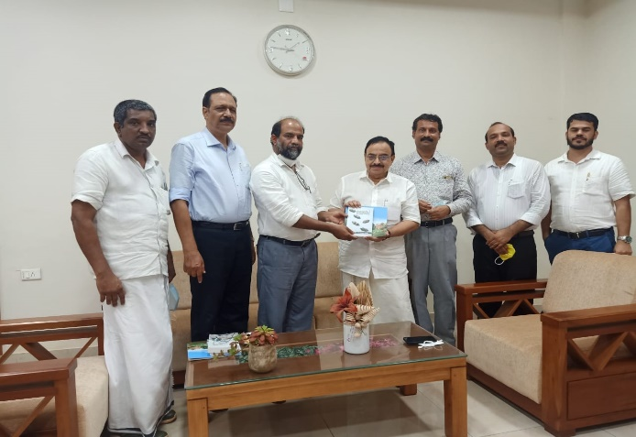

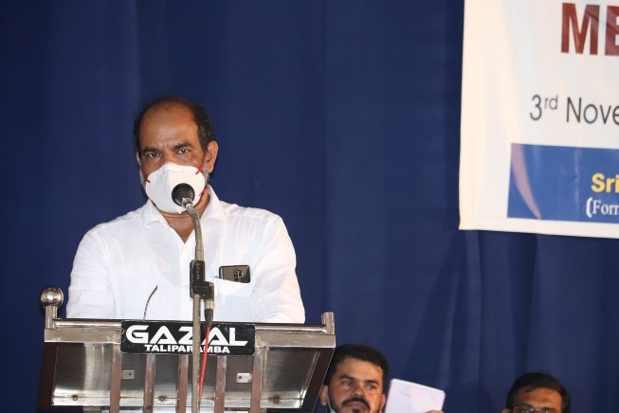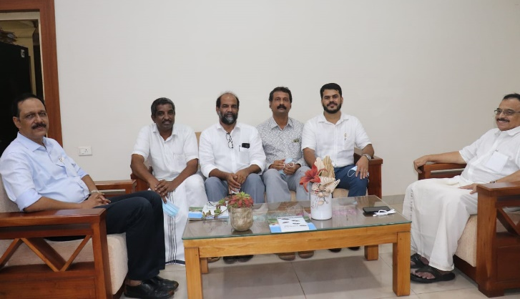

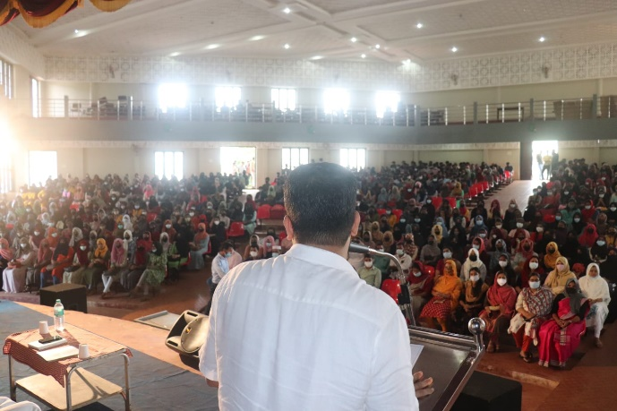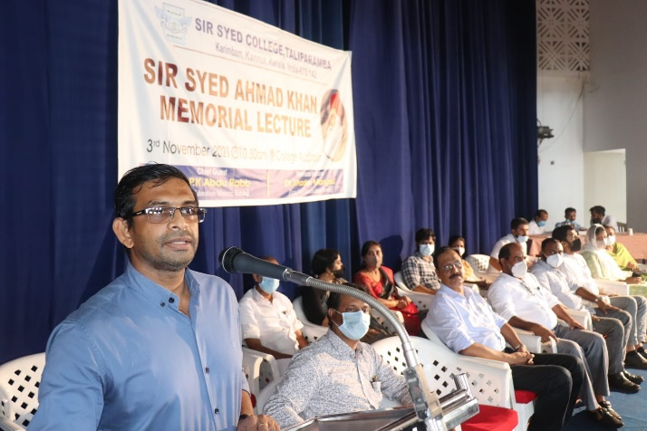

ഹിസ്റ്ററി ഡിപ്പാർട്മെൻറിൽ നിന്നും വിവിധ സർവകലാശാലയിൽ ഉപരിപഠനത്തിന് അവസരം ലഭിച്ച വിദ്യാർത്ഥികൾക്ക് കണ്ണൂർ സർവകലാശാല മുൻ വൈസ് ചാൻസലർ സ്നേഹോപഹാരം നൽകുന്നു
Gift distribution to students from History dept, who are admitted to different universities for Post Graduation in History- 03-11-2021 (As part of Sir syed Ahmad Khan Memorial Lecture)
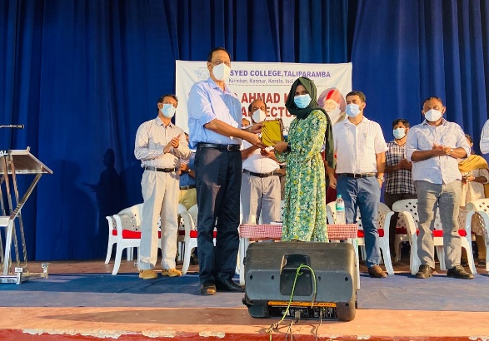
Shahifa P V, admitted at Hyderabad Central University
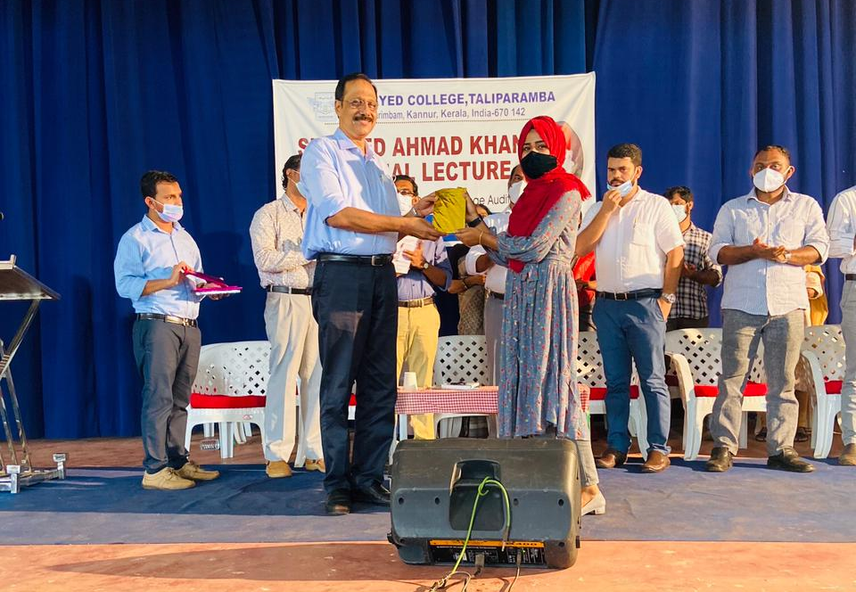
Faheema K, admitted at Pondicherry Central University
Fasila P, admitted at Sree sankaracharya Sanskrit University

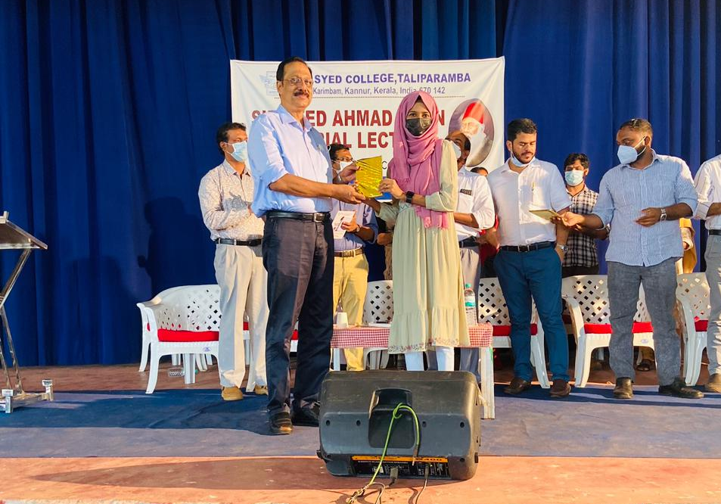
Safoora K, admitted at Pondicherry Central University
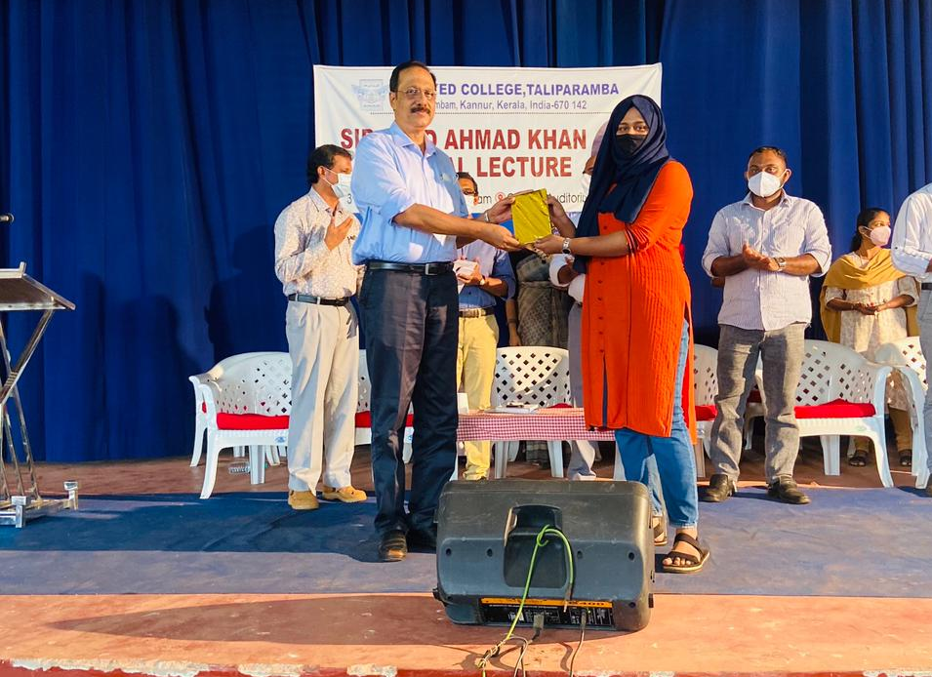
Fathima Zahara P K , admitted at Pondicherry Central University
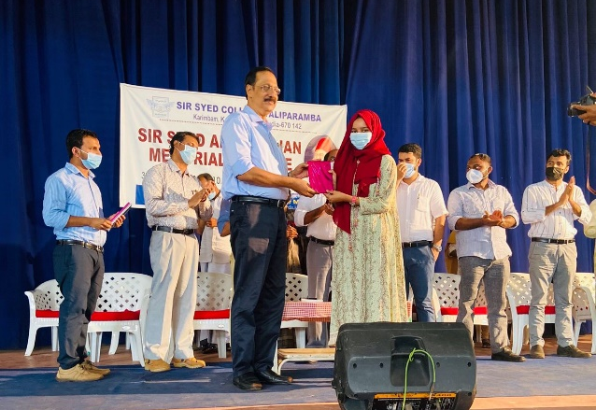
Shahana P – Kannur University Mangattuparamba Campus
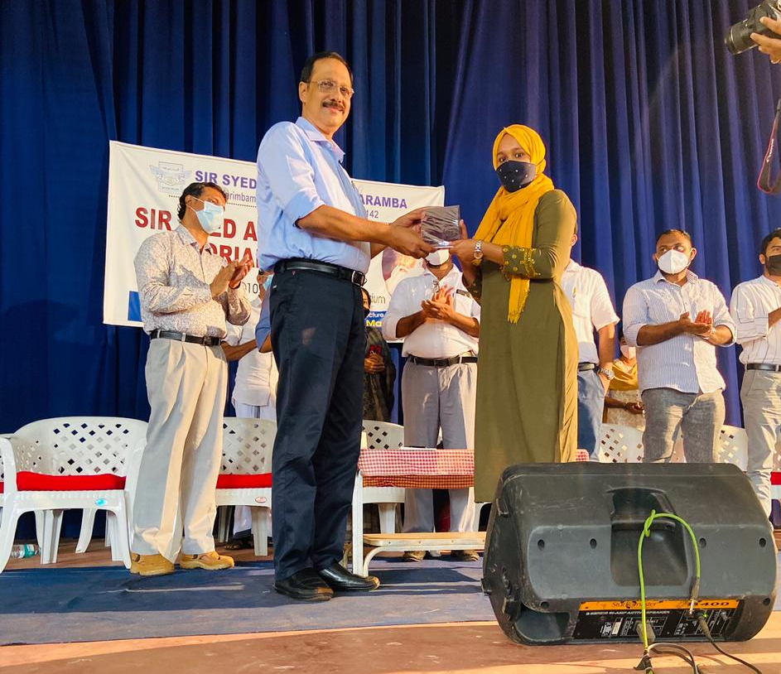
Shifana M K - Kannur University Mangattuparamba Campus
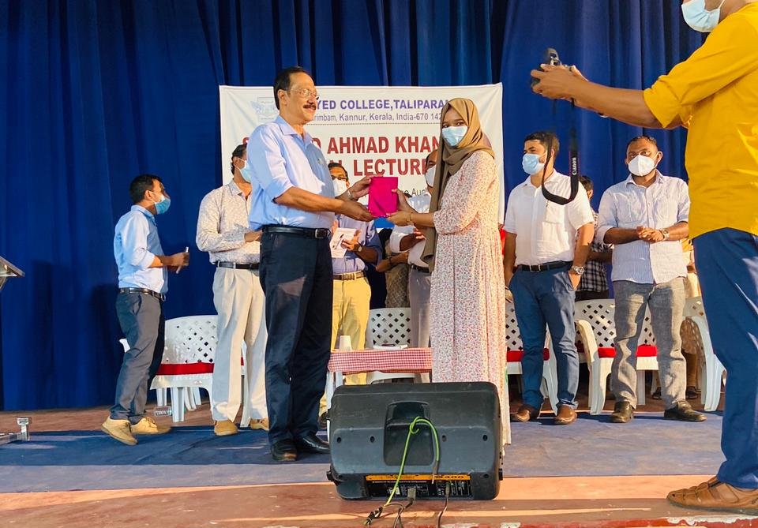
Shaniba C K - Kannur University Mangattuparamba Campus

- Inauguration of History Association and History Club
COMIENZO’22 – 15th February 2022

Department of History Conducted inauguration of History Association and History Club on Tuesday, 15th February 2022 at College Seminar Hall. It was Inaugurated by famous Television Journalist Mr. Nishad Rawther, Media One TV. The programme scheduled from 10.00 AM to 12.00 PM.
Mr. Hydarali A, HoD of History delivered welcome speech and It was presided over by Dr. Ismail Olayikkara, Principal, Sir Syed College. The programme was felicitated by Mr. Thwahir. P.H, Mr. Faisal M K and Mr. Shiraz. Mr. Muhammed Jadheer M, Association Secretary, delivered Vote of thanks.

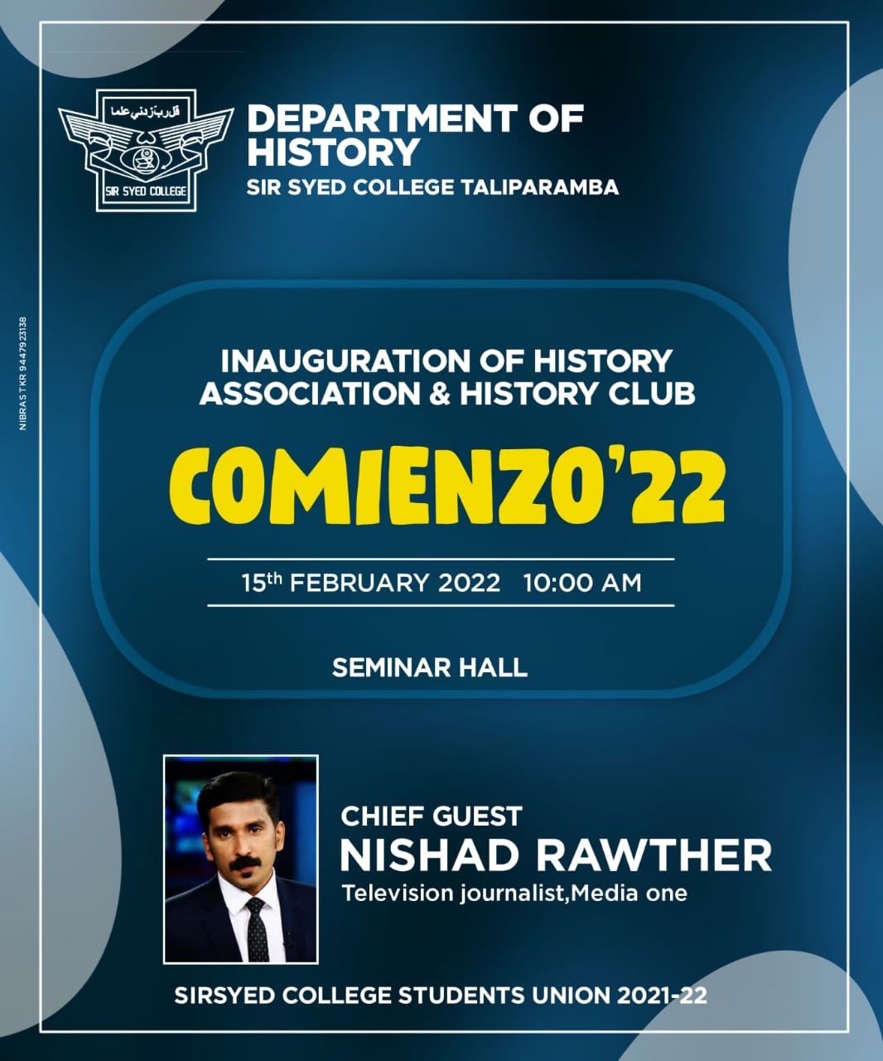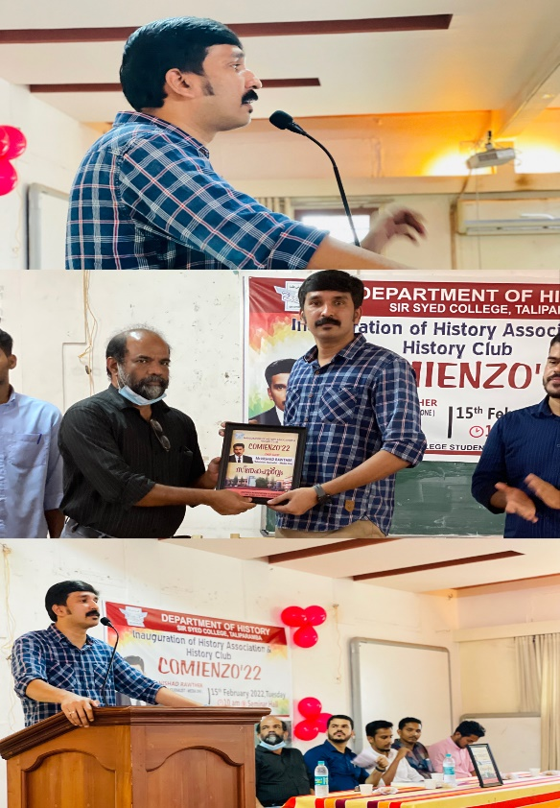

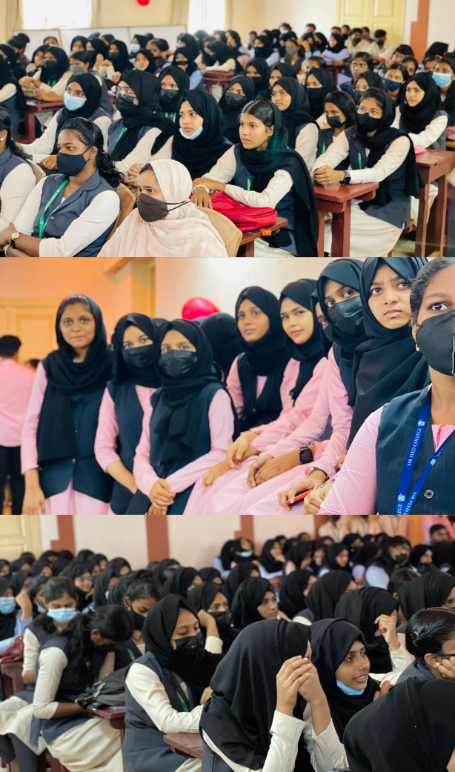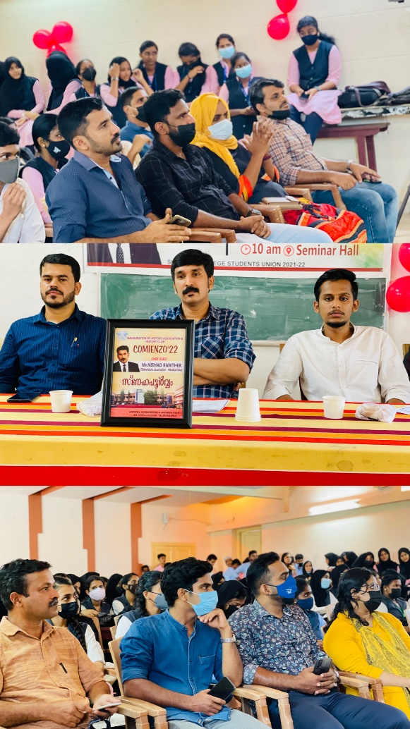

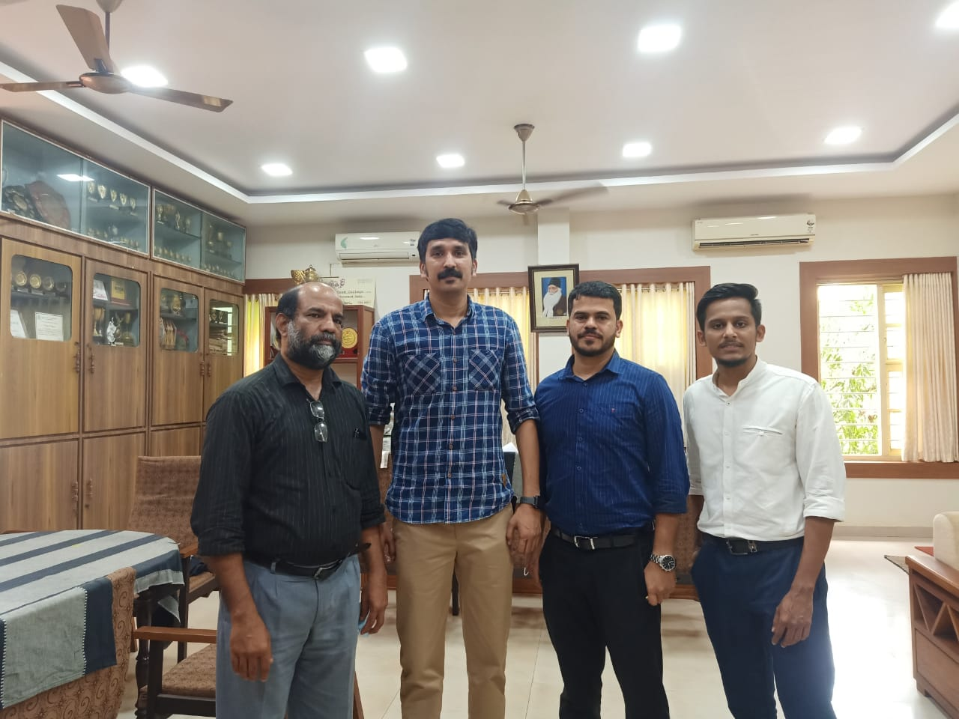

- Historical Site Visit at Wayanad – 10-03-2022

History Club of Sir Syed College Conducted a one-day Historical site visit at Wayanad on Thursday, 10th March 2022. 48 students from first, second, and third year BA History and Mr. Hydrali and Mr. Thwahir, PH have participated. Students visited Edakkal Cave, Banasura Sagar Dam and Karapuzha dam.
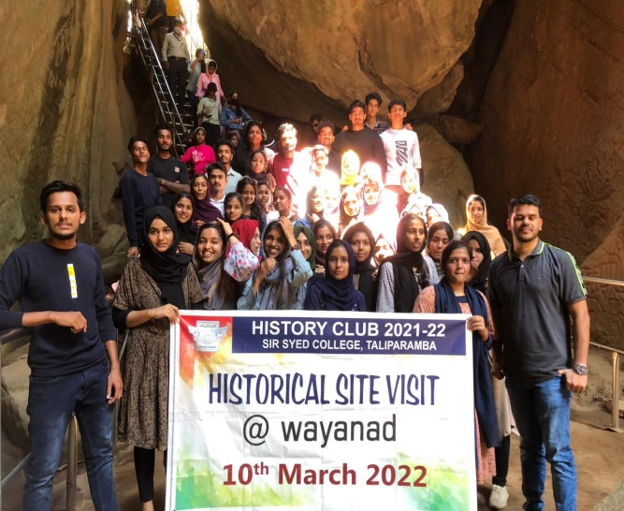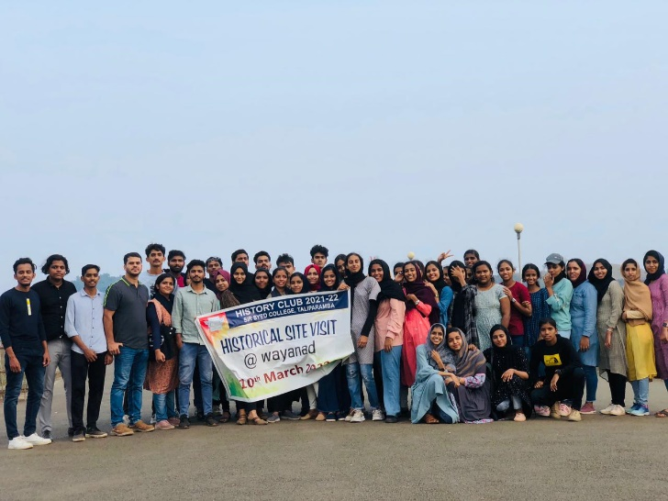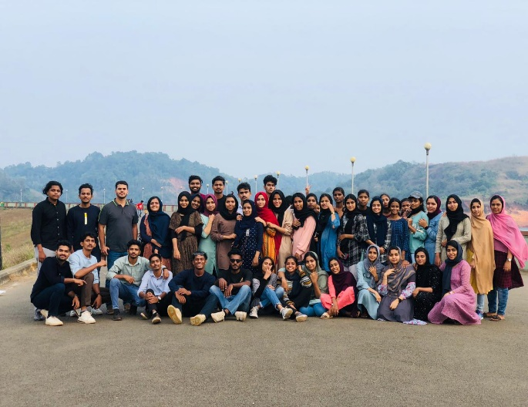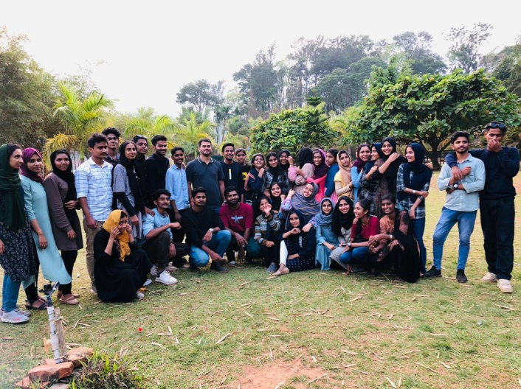

- Student felicitation
Department of History conducted students felicitation programme for Fourth Semester students who scored A+ and A grades in first semester examination on 23rd February 2022. The main motive of organizing student felicitation program is the concept of pulsating and appreciating the imaginative instincts and acts of brilliant and talented students of history Departments. Mr. Hydarali A, Head of the Department delivered welcome speech and 19 students were felicitated by Dr. Ismail Olayikkara, Principal of Sir Syed College. It was attended by Mr. Shanavas S M, Convener of Academic Committee and faculties and students from history department. Mr. Thwahir. P.H, Faculty of history delivered vote of thanks.

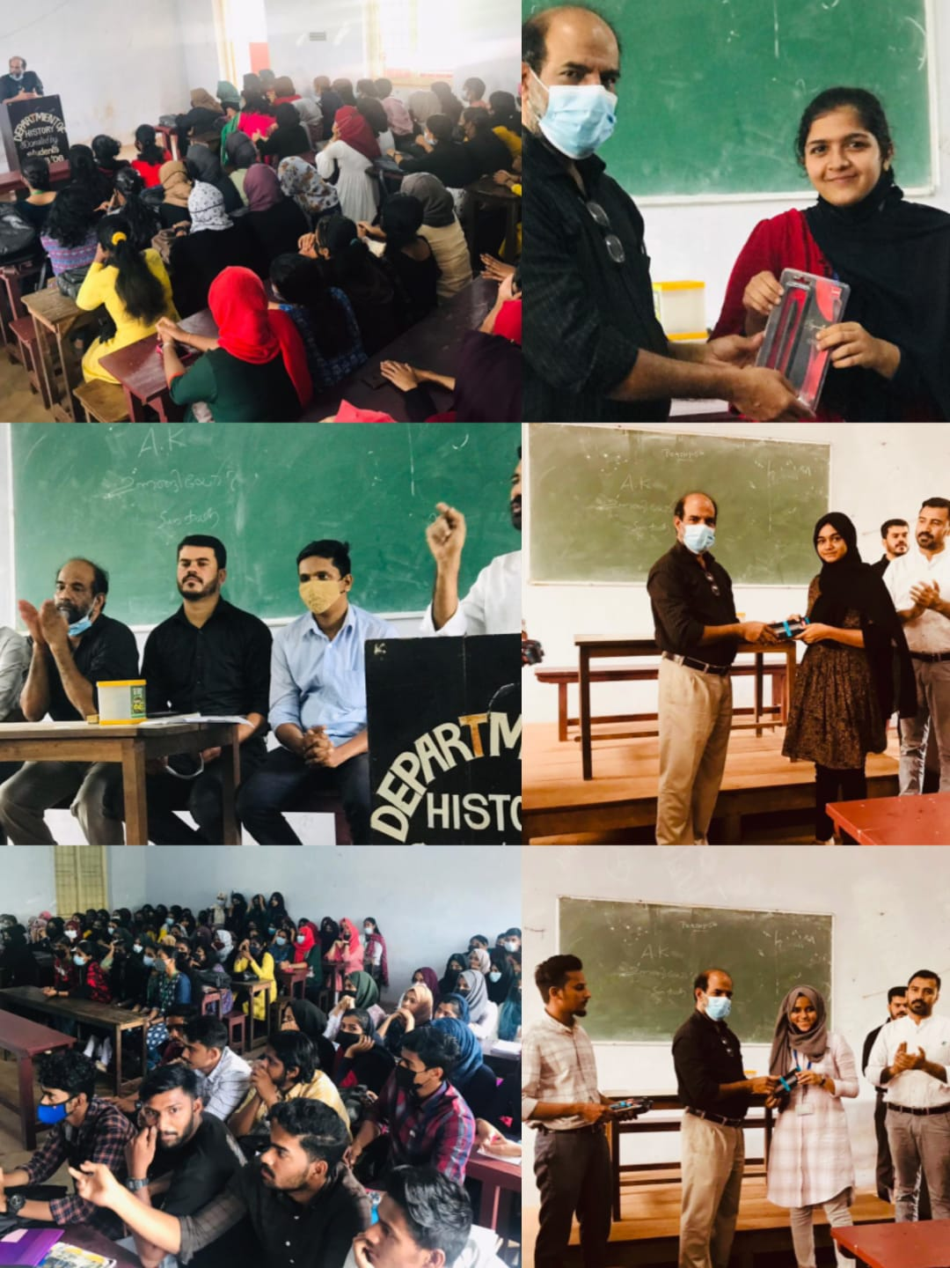
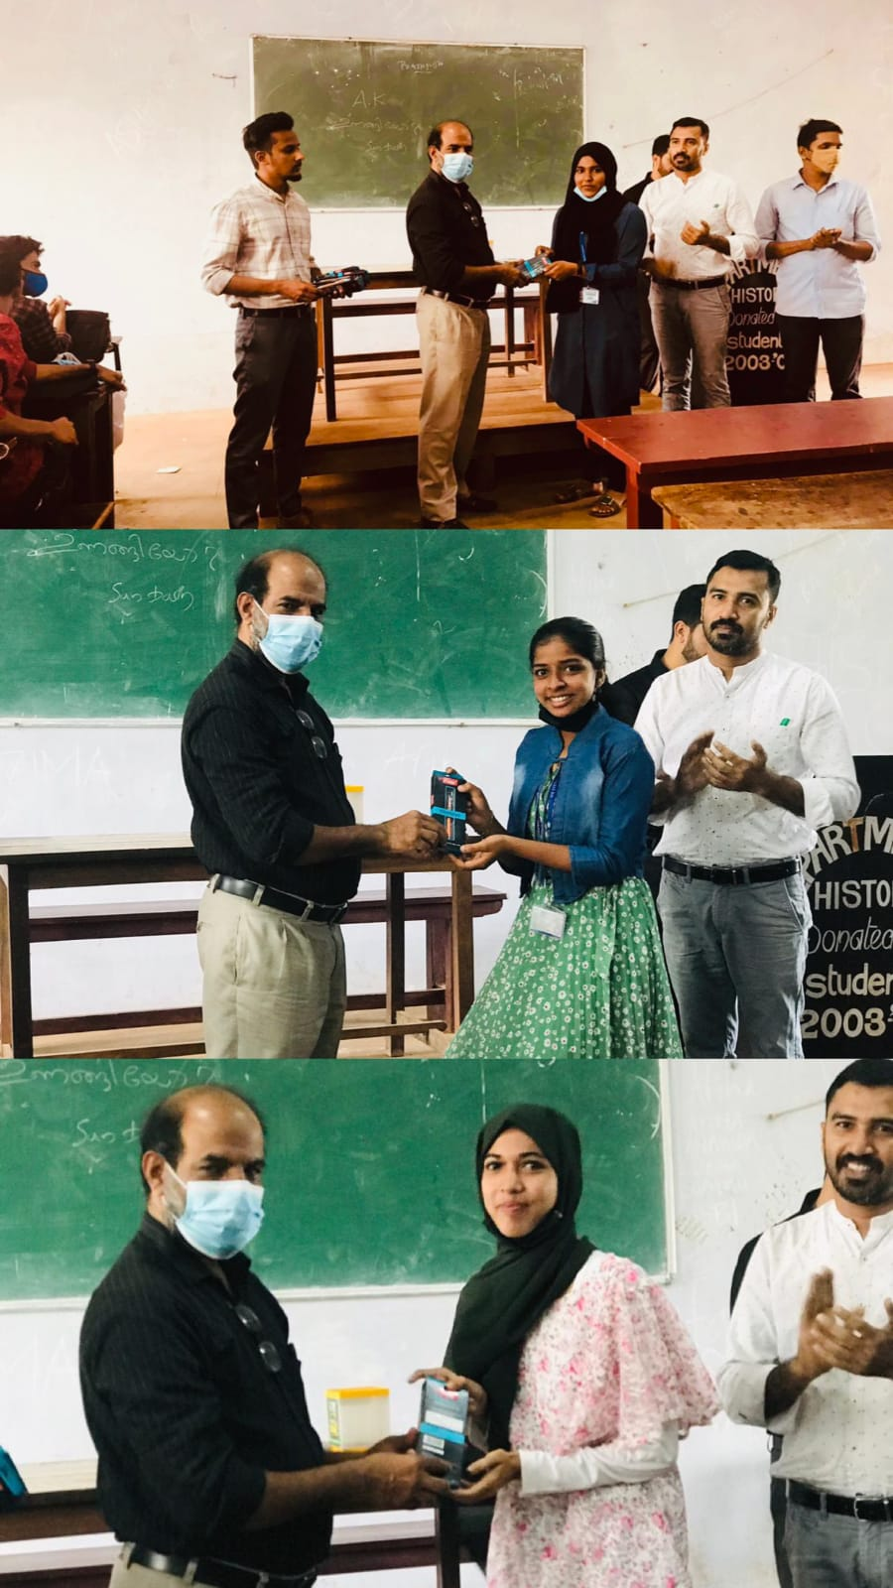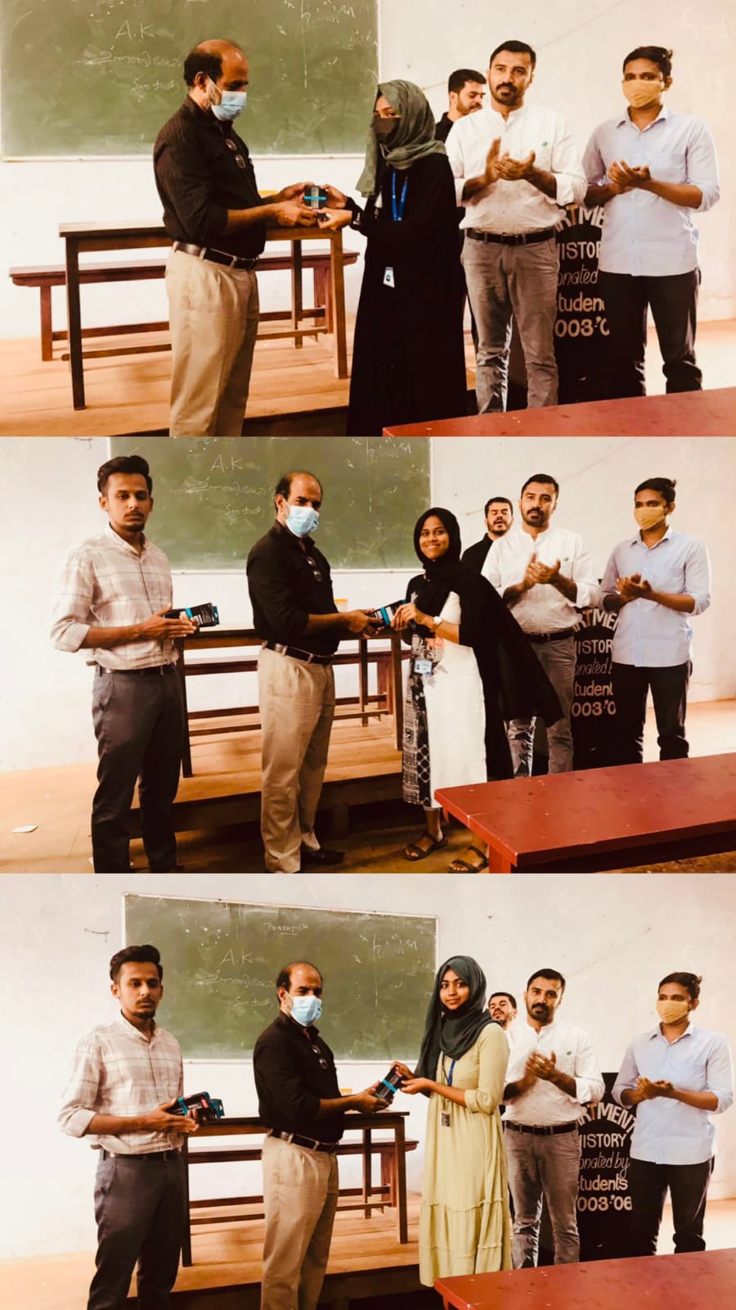

- Invited talk on Doing history: Tools and Techniques – Wednesday, 23rd March 2022
Department of History conducted an Invited talk on Research methodology titled as “Doing history: Tools and Techniques” on Wednesday, 23rd March 2022 at 1.30 PM onwards. The program aimed to provide guidance on historical research for students, especially for final semester students for their degree project on local history. Dr. Muhammed Sirajudheen K, Assistant professor of history, Government Brennen College, Thalassery was the resource person. Mr. Thwahir. P.H, Assistant professor of history delivered welcome speech and it was presided over by Head of the Department Mr. Hydarali A. The session was inaugurated by Dr. Ismail Olayikkara, Principal of Sir Syed College and it was felicitated by Dr. Tajo Abraham, IQAC Coordinator of Sir Syed College, Dr. Fazal E, Secretary of Staff Association and Mr. Faisal M K, Assistant professor of history. Mr. Jadheer M, History Association Secretary delivered vote of thanks.

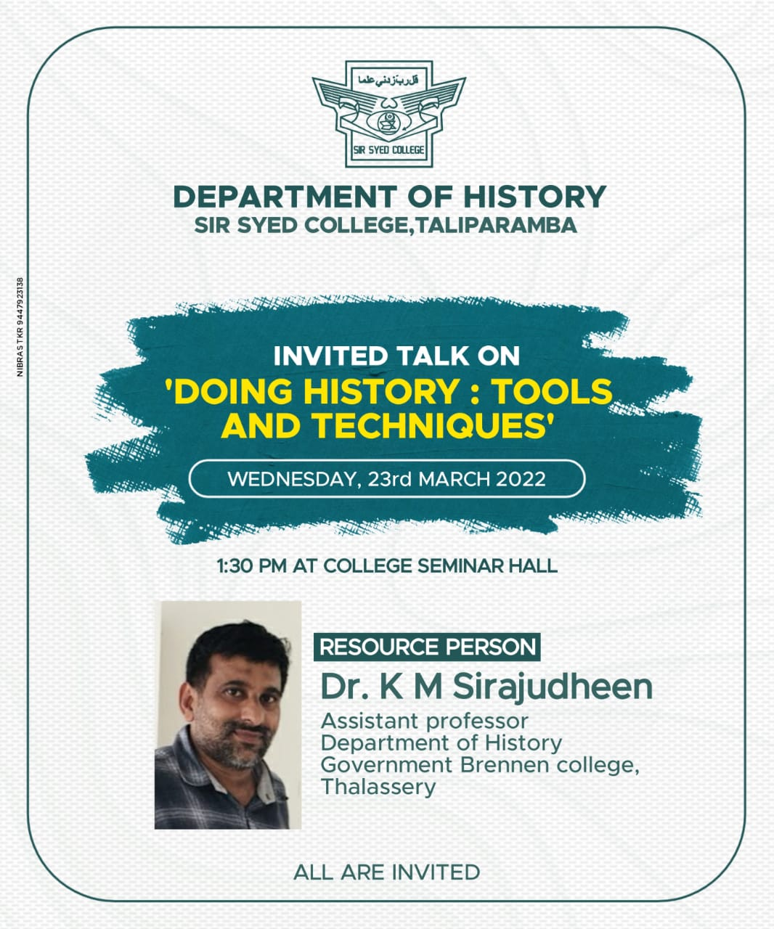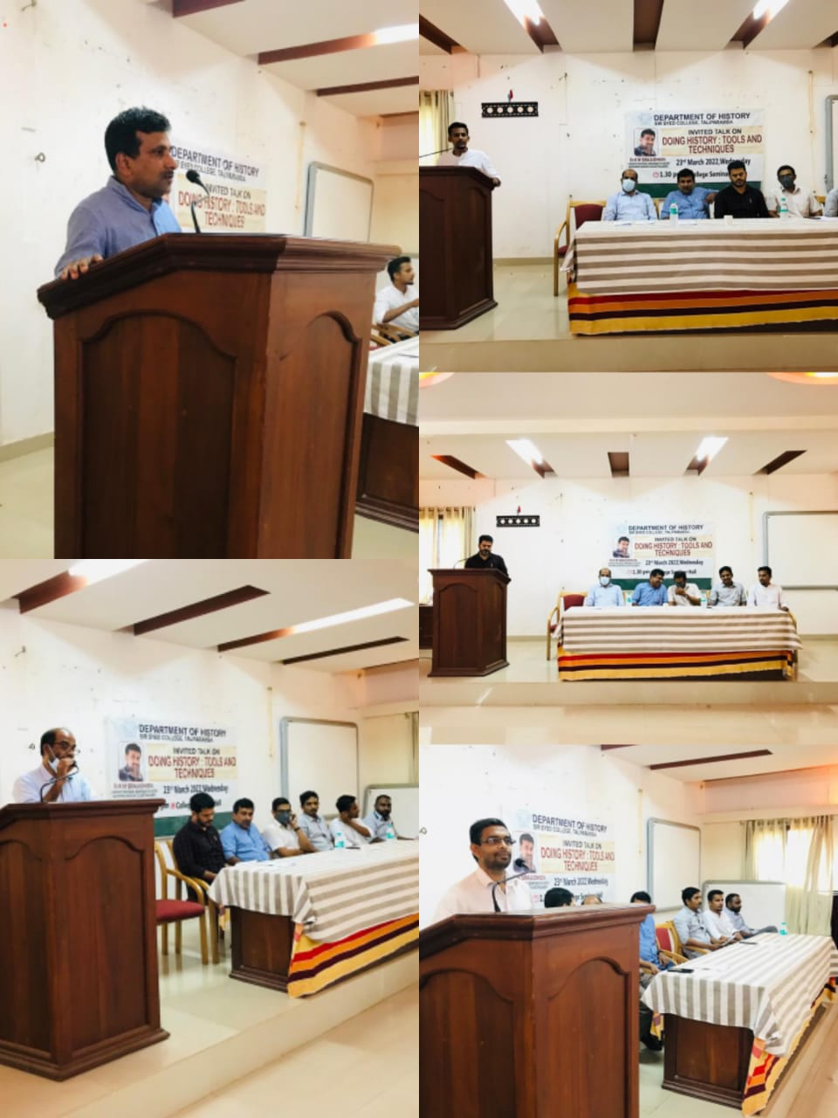
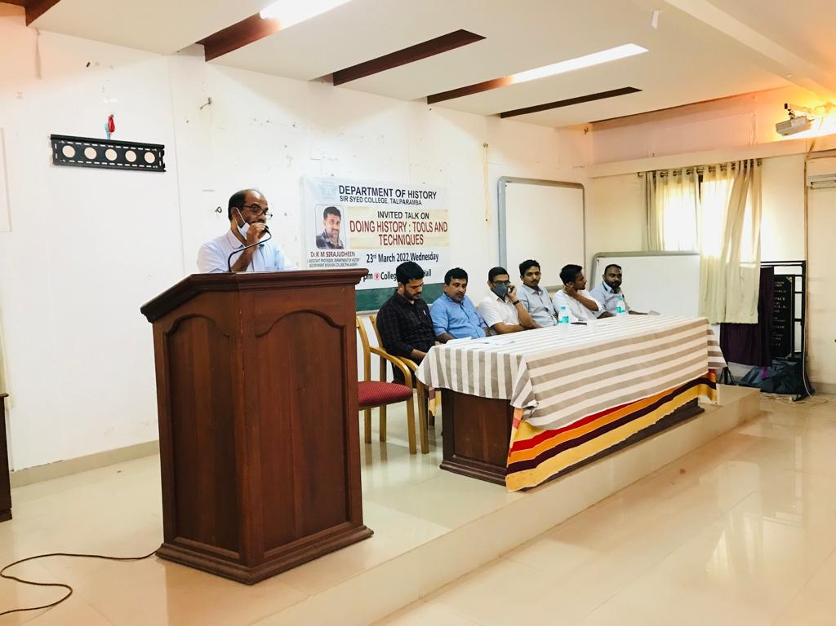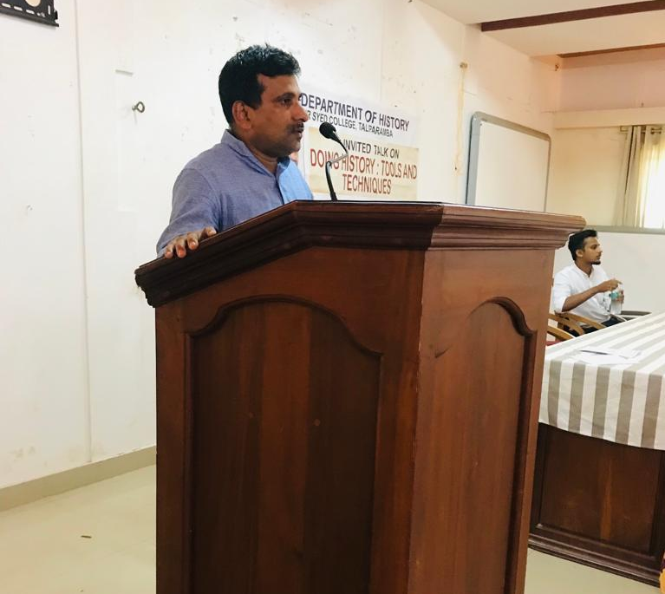
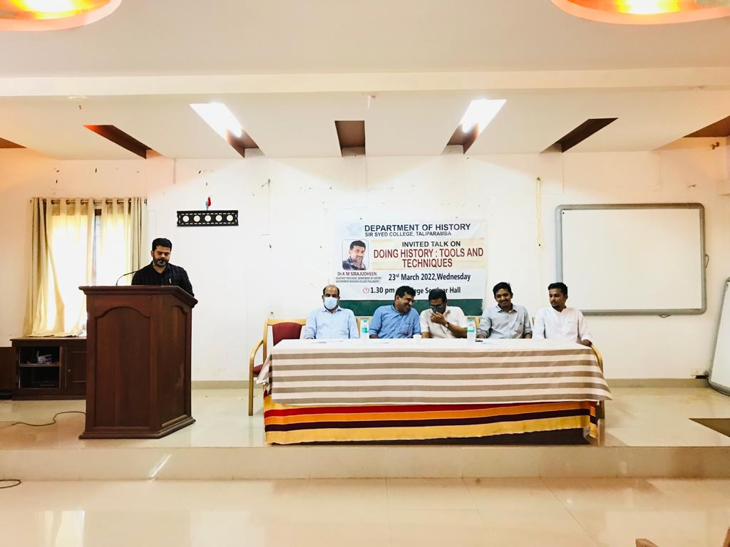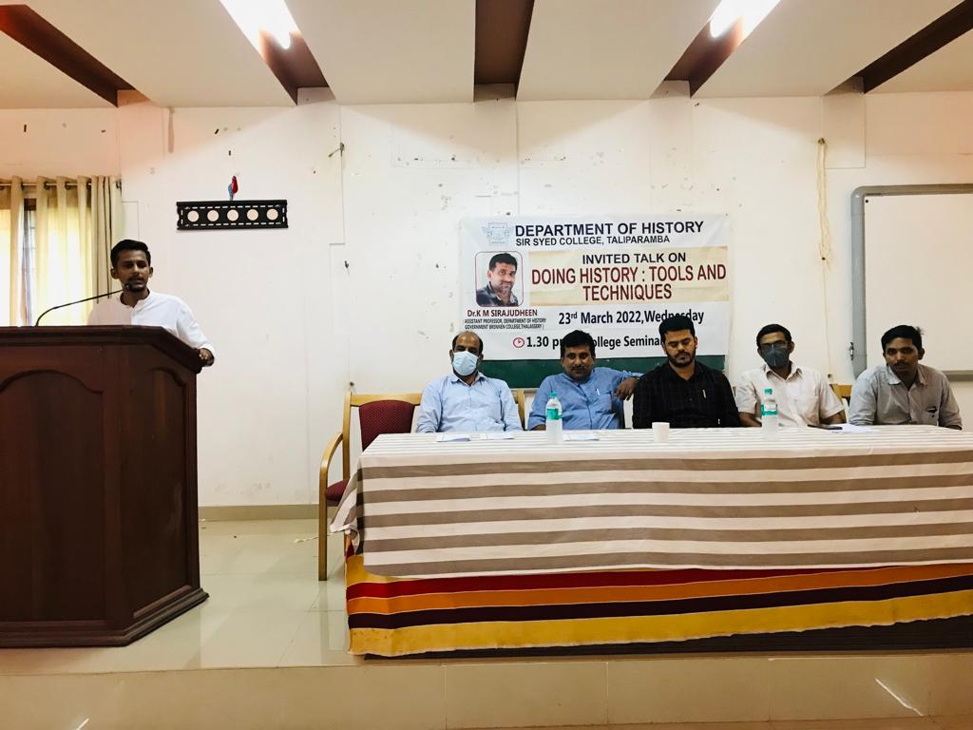

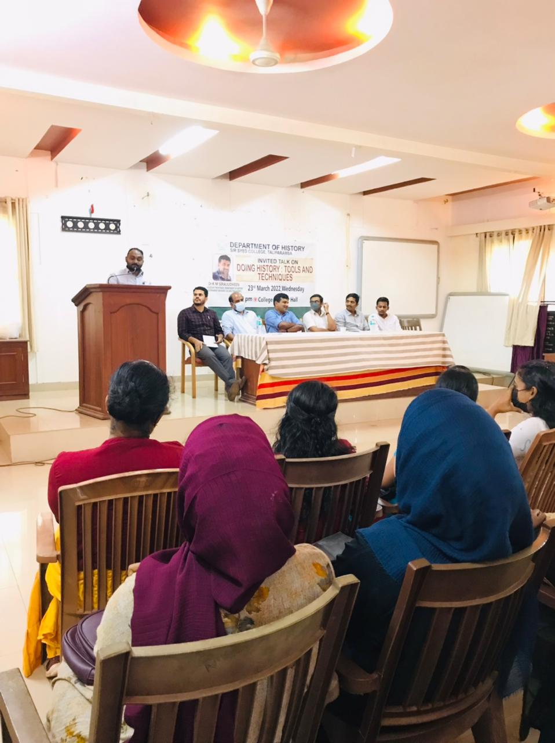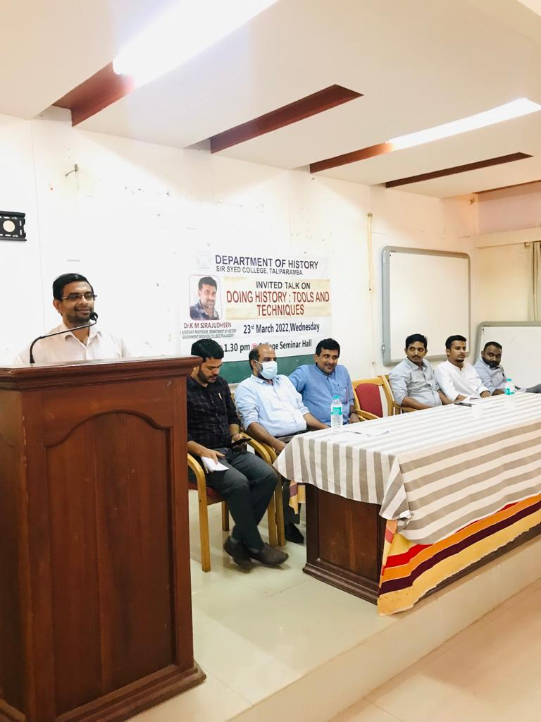

- INTER – DEPARTMENTAL QUIZ COMPETITION ON INDIAN HISTORY
30-03-2022 – WEDNESDAY

History club of Sir Syed College conducted an inter-departmental quiz competition on Indian history on Wednesday, 30th march 2022. A total of 12 teams of two members participated in the competition. Christy Jills and Midhun from second semester Bsc Physics were the winnners. Team History of Muhammed Savad and Muhammed Rashid from sixth sem History secured second position. Mr. Thwahir. P.H, Assistant Professor of history and conviner of history club distributed cash prize of Rupees 1500 and 1000 respectively for the winners.

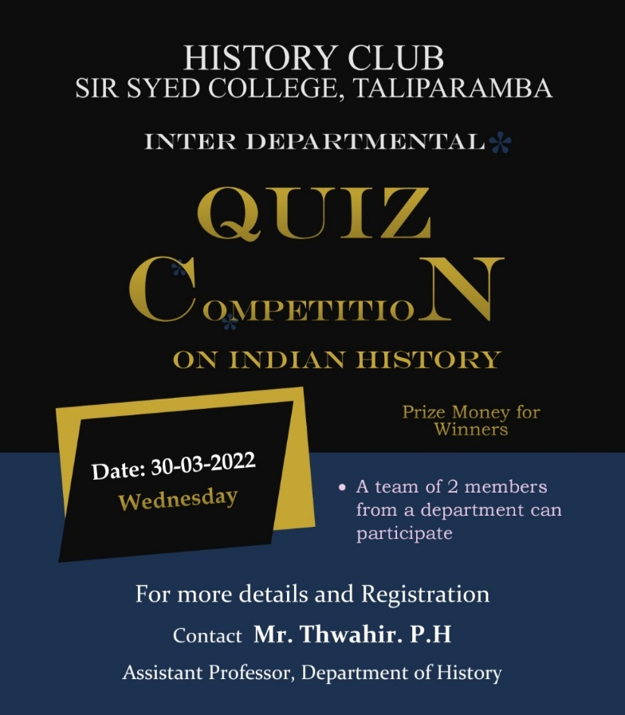
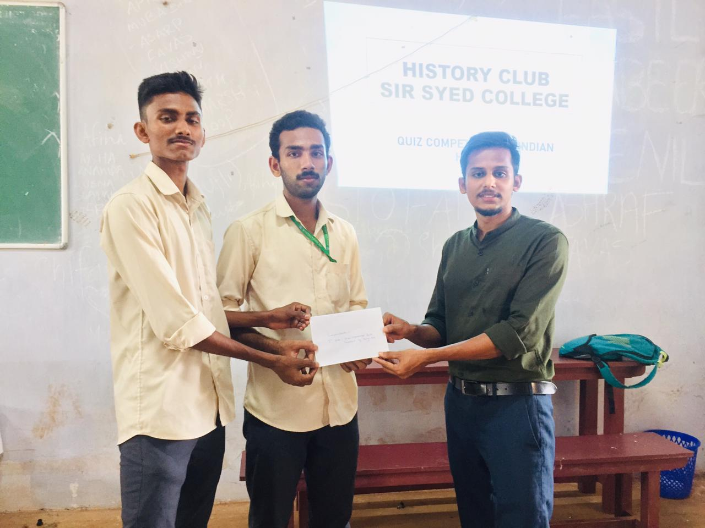
First prize- Department of Physics

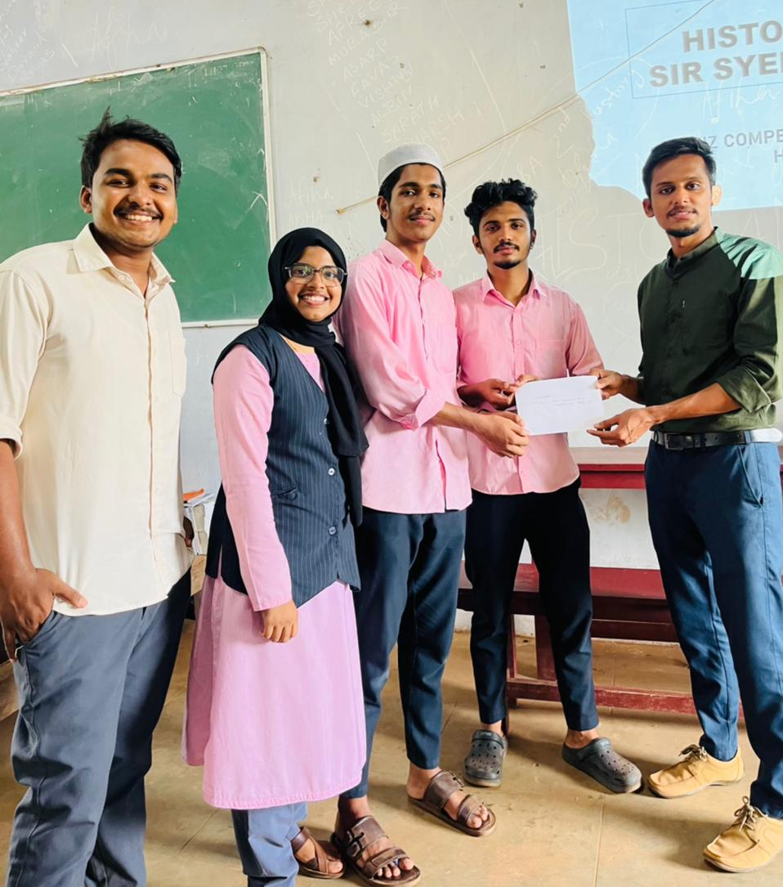
Second prize – Department of History
- EXODUS 2022- A RESIDNTIAL CAMP
1 - 2 April 2022
History Association conducted Exodus 2022, a residential camp for history students on 1st and 2nd April 2022. The session aimed to provide career orientation, motivation and personality development for the students. Mr. Thwahir. P.H, Assistant professor of history delivered welcome speech and presided over by Mr. Hydarali A, Assistant Professor and HoD of History department. It was inaugurated by Dr. Ismail Olayikkara, Principal of Sir Syed College, Taliparamba and falicitated by Dr. Abdul salam, Asst. Professor of Botany. Special class and training was given by Mr. Navas Mannan, Assistant Professor of Malayalam, Sir Syed College Taliparamba. He engaged students with motivation, games and personal training. Students arranged cultural programs, camp fire, night talk, games…etc. The camp ended with breakfast on 2nd april 2022.

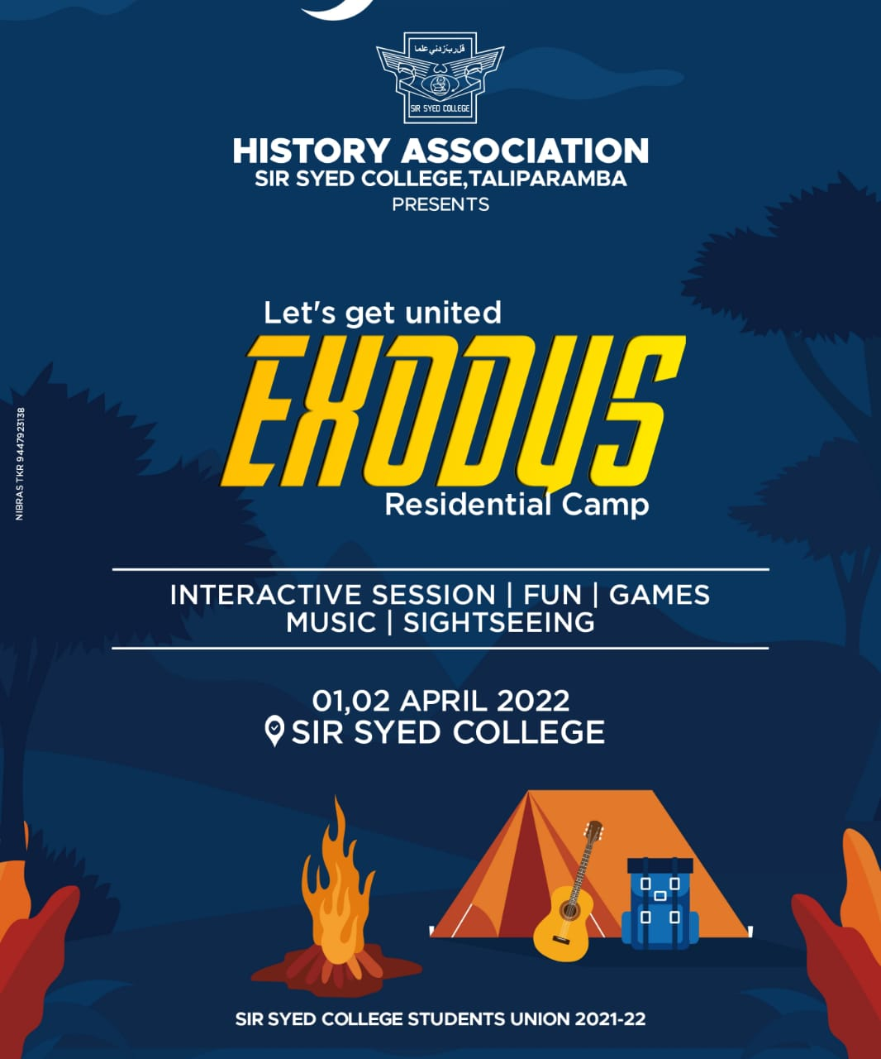
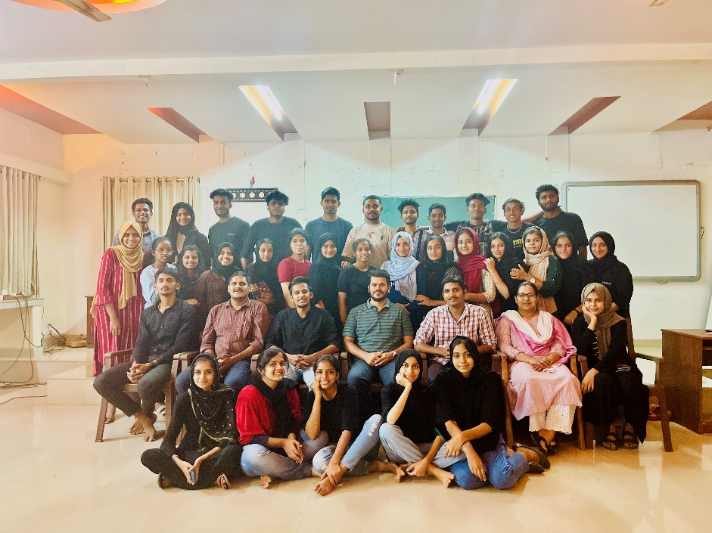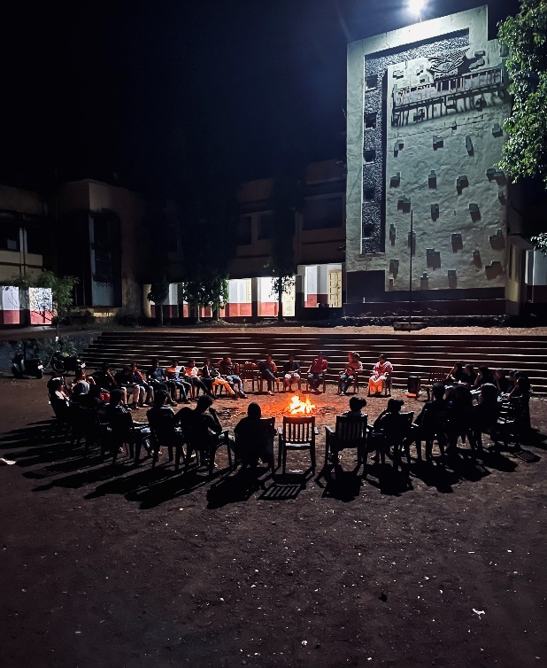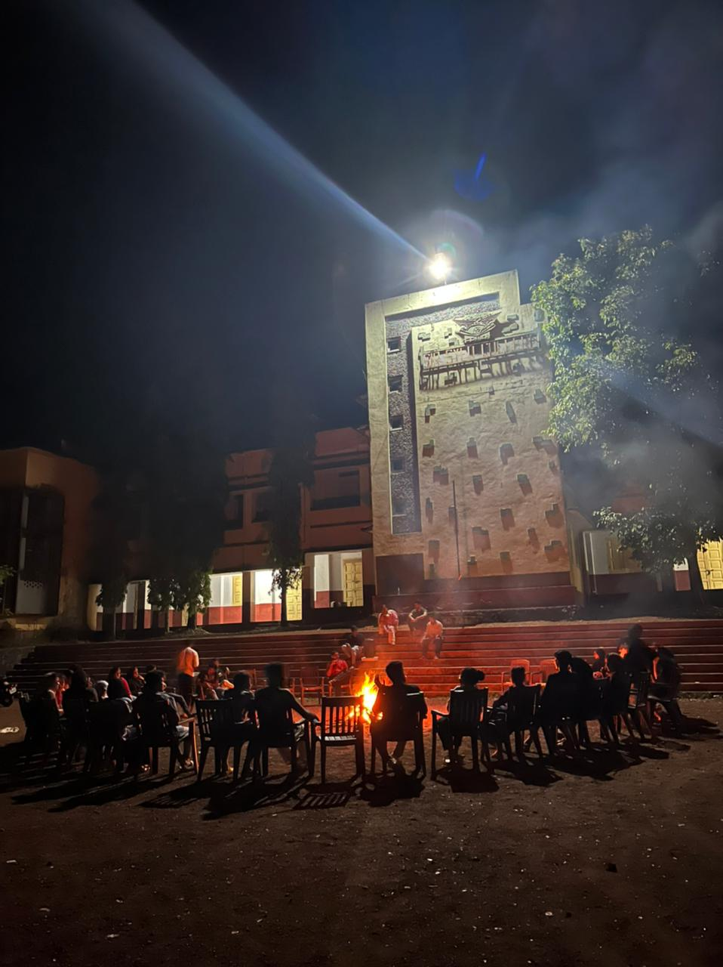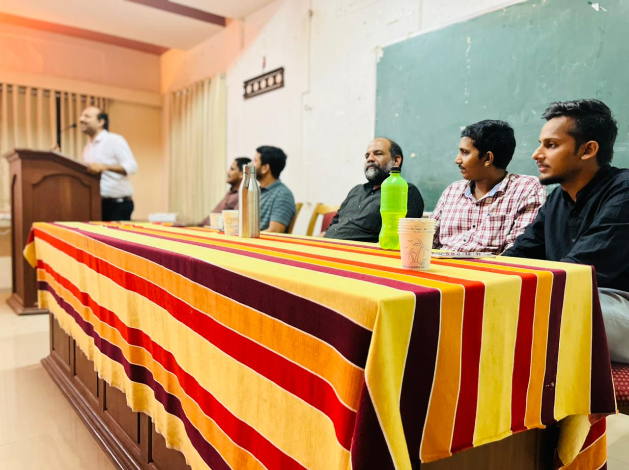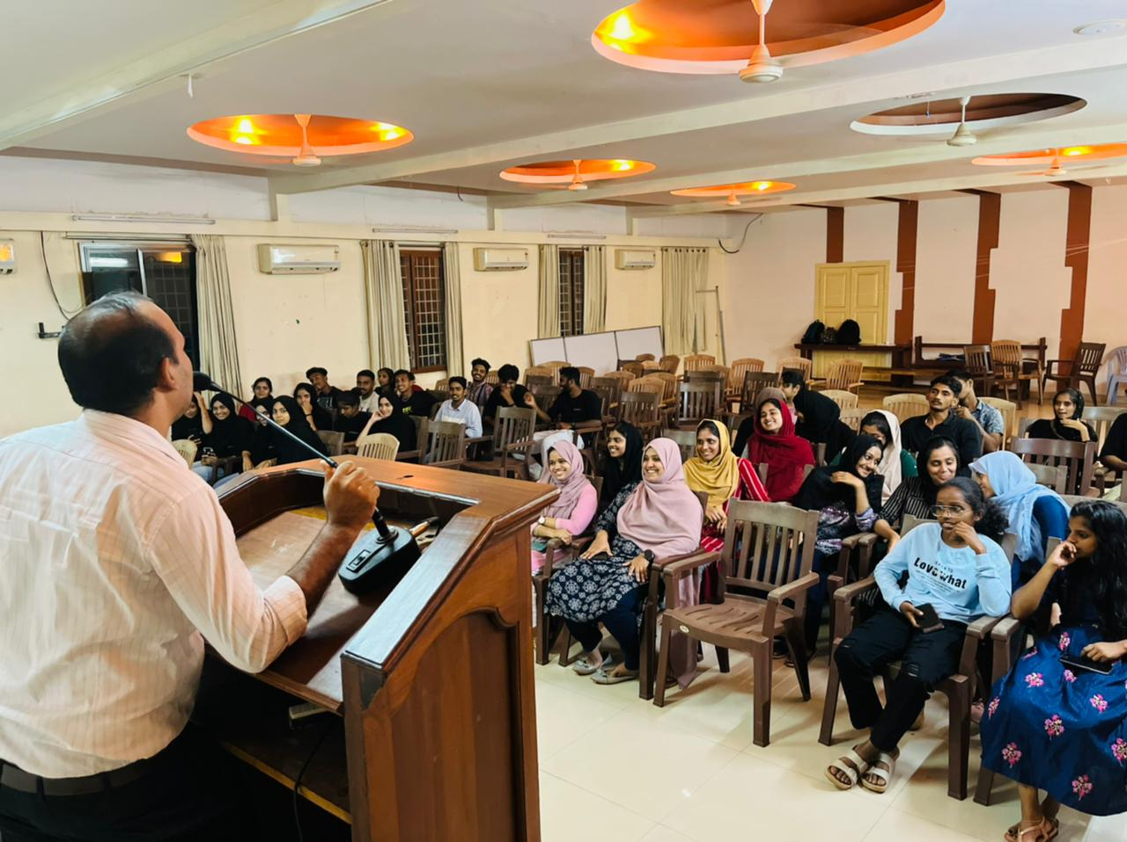

Student’s Achievements

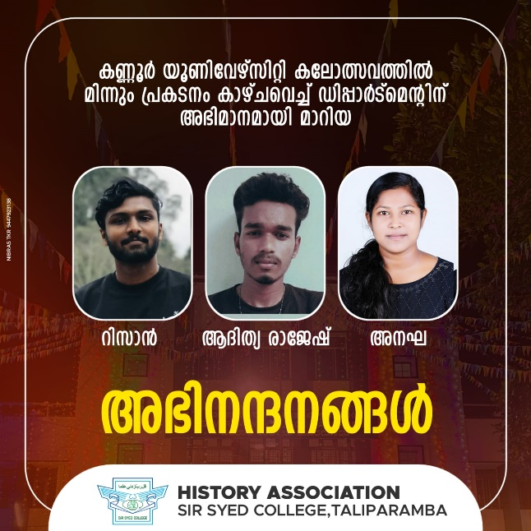

Three Students from History Department secured better ranks in University Arts festival held at Government College, Kasaragode. Muhammed Rizan from fourth semester history – Mapilappattu group, Aditya Rajeesh – Folk song Malayalam and Anagharaj – group Dance

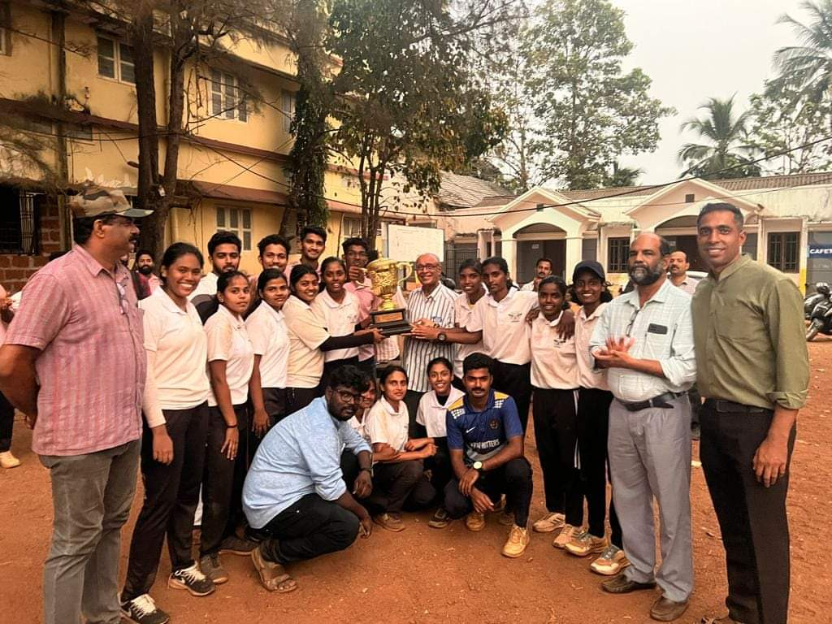
Sir syed college won Kannur university women cricket championship. Three of them belongs to Second Sem BA History, Aswathi K M, Nasiya Sulthana and Shibina

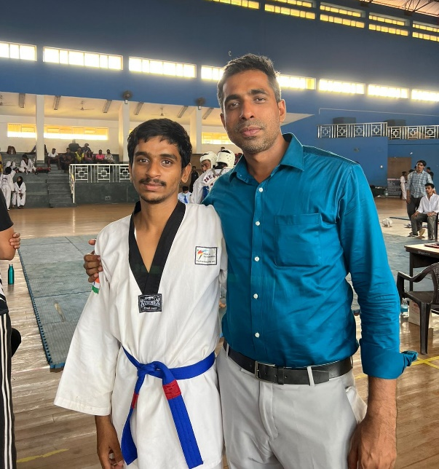
Shajil Sheikh secured silver medal in Kannur University inter collegiate Taekwondo championship

