ANNUAL REPORT (2022-23)
DEPARTMENT OF HISTORY

- INVITED TALK ON “INDIAN DEMOCRACY: A CONSTITUTIONAL READING”
19/09/2022 - MONDAY

Department of history in association with IQAC and IDis -22 conducted a talk as part of azadi ka Amrit mahotsab, India @75, celebration of India's 75th independence day on 19th September 2022, Monday from 10.30 AM to 12.30 PM at college Auditorium.
Mr. Hydarali A, Head and Assistant Professor, Department of History delivered Welcome speech and Dr. Ismail Olayikkara, Principal, Sir Syed College presided over the function. The Chief Guest of the Program Dr. Arun Kumar, Senior Journalist and Assistant Professor, Department of Political Science, Kerala University delivered his talk on Indian Democracy: A constitutional Reading. He talked about various issues related to Democracy, Indian Constitution and neo fascism. Students and teachers actively participated in Interactive session after his talk. Principal handed over a gift to the chief Guest Dr. Arun Kumar.
Dr. Tajo Abraham (IQAC Coordinator), Dr. Mumthaz TMV (Secr. Staff Association), Dr.Siraj PP (PTA Secretary), Renjith MV(Faculty of history) were presented. Thwahir. P H, Assistant Professor, Department of History delivered Vote of Thanks.

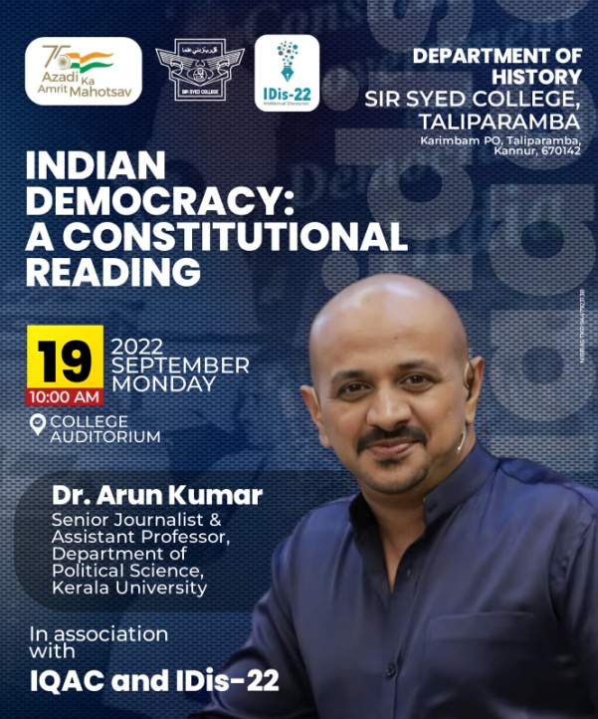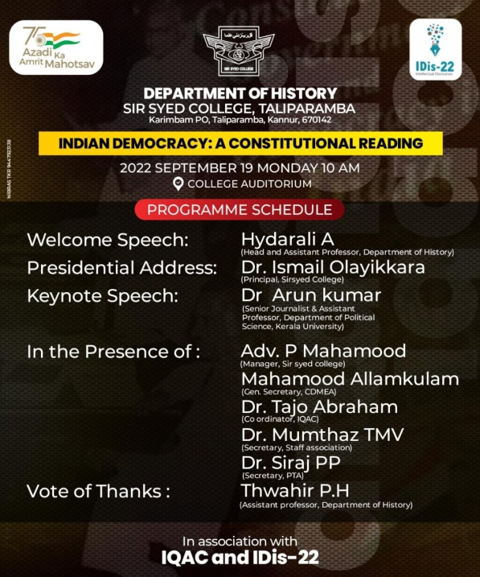
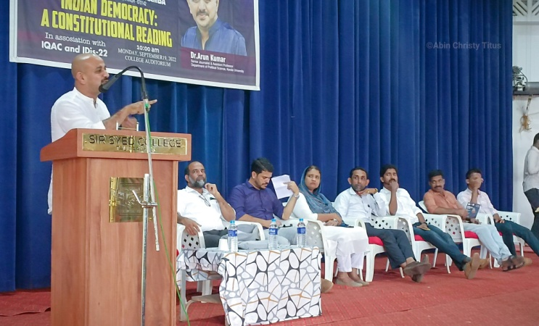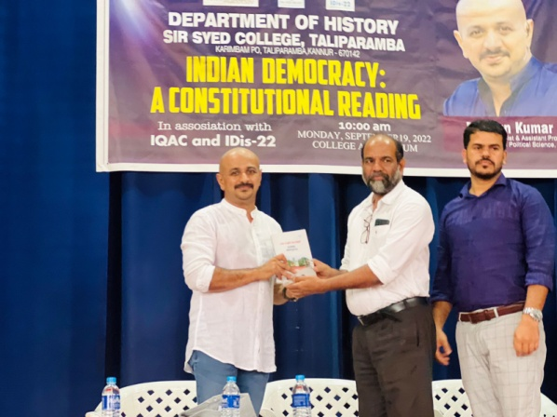
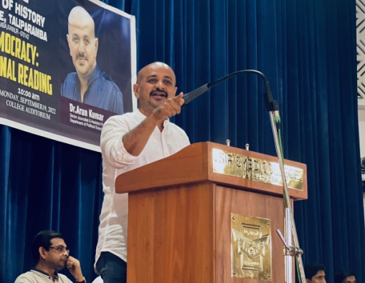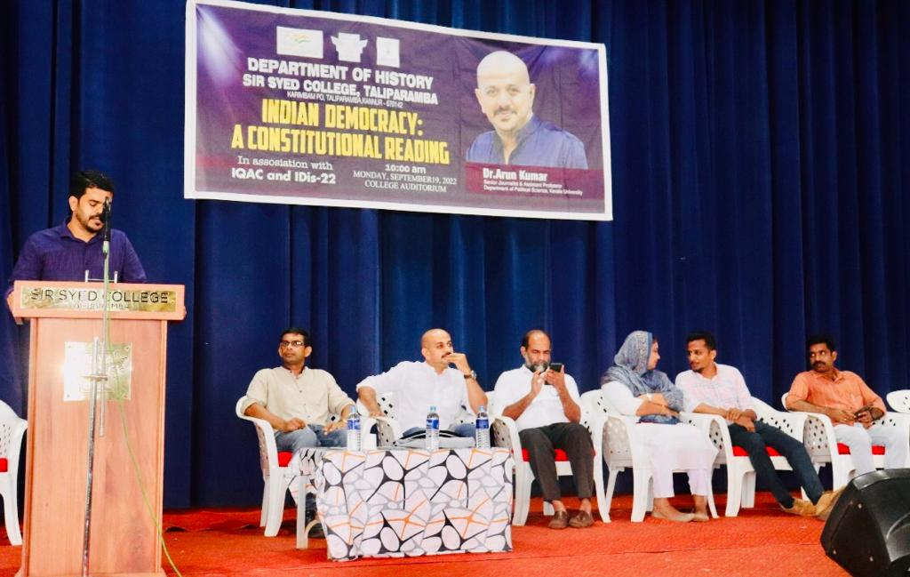
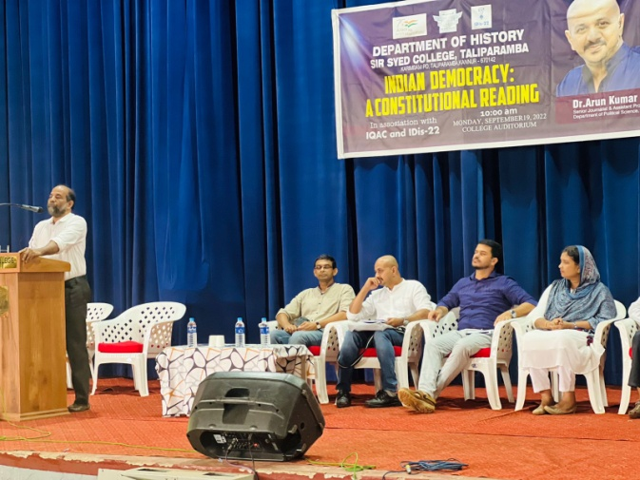

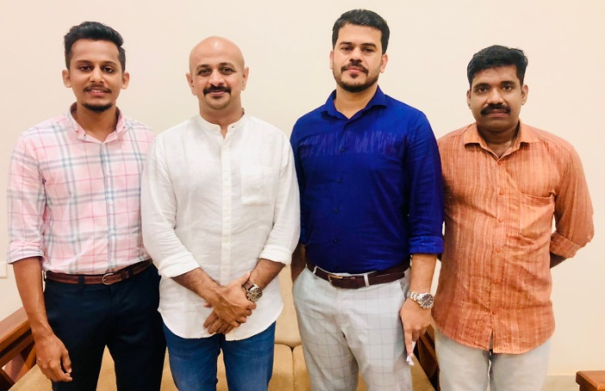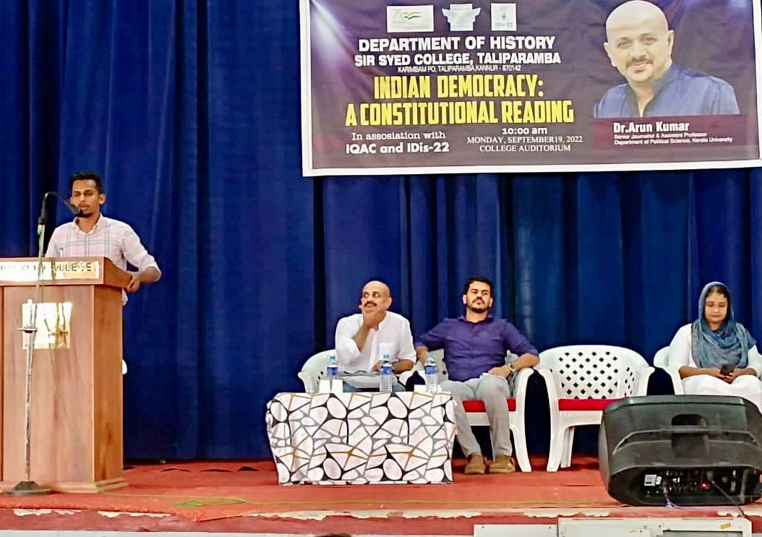

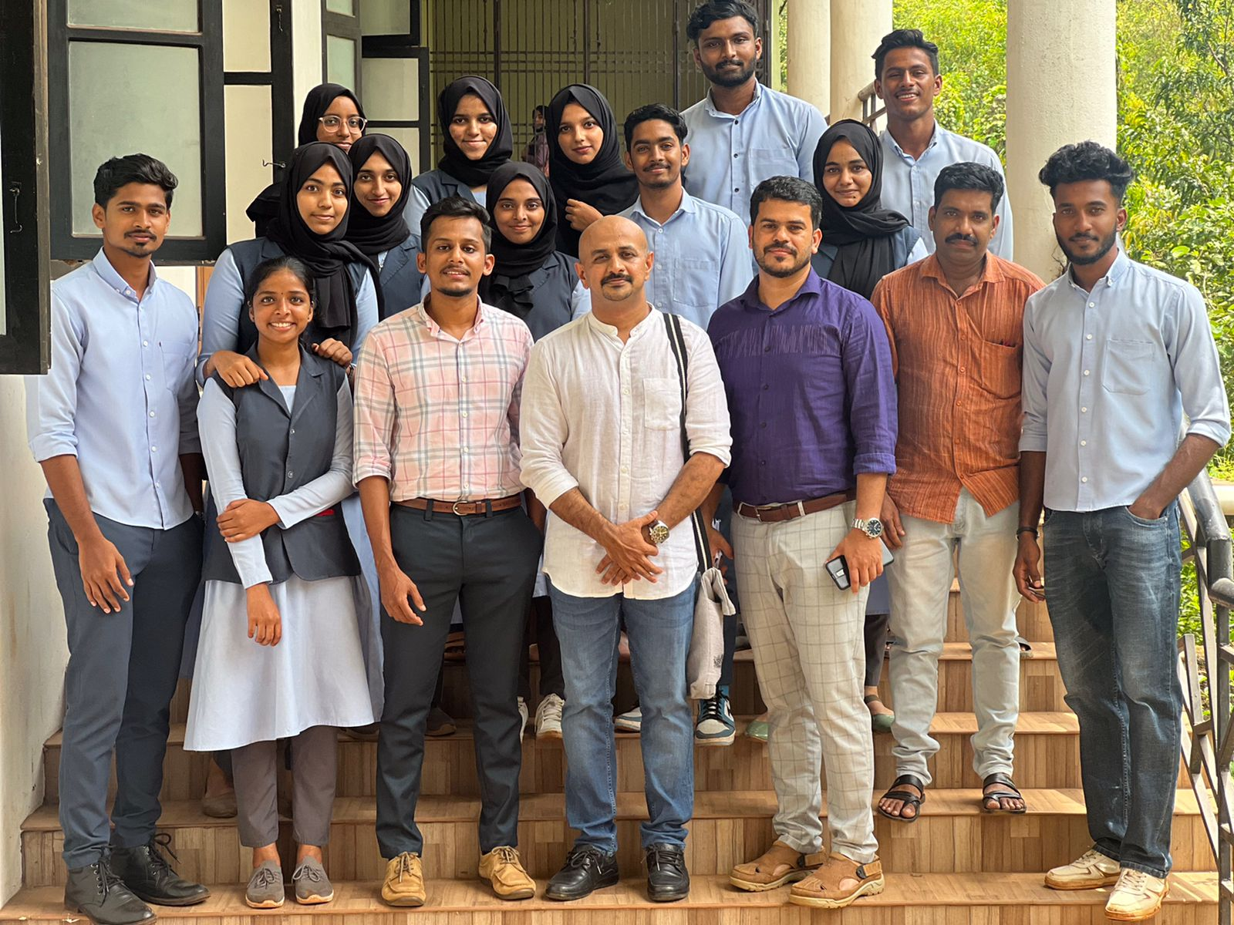

- INAUGURATION OF HISTORY ASSOCIATION 2022-23
History Association of Sir Syed College was inaugurated by Dr. Malavika Binny, Assistant Professor, Department of History, Kannur University on 10th November 2022, Thursday at College Seminar Hall. Hydarali A, Head of the Department of History delivered welcome speech and presided over by Dr. Ismail Olayikkara, Principal of Sir Syed College. Mr. Thwahir Ph, Mr. Renjith M V, Mr. Siyad K felicitated the function. Association Honored Ashikha Khanam B K, Alumni of the Department for selected for post graduation studies in history at Central University of Utharakhand and Karnataka. Fathimath Hanna, Association Secretary delivered Vote of Thanks. It was concluded at 12.30 PM with the cultural activities of students.
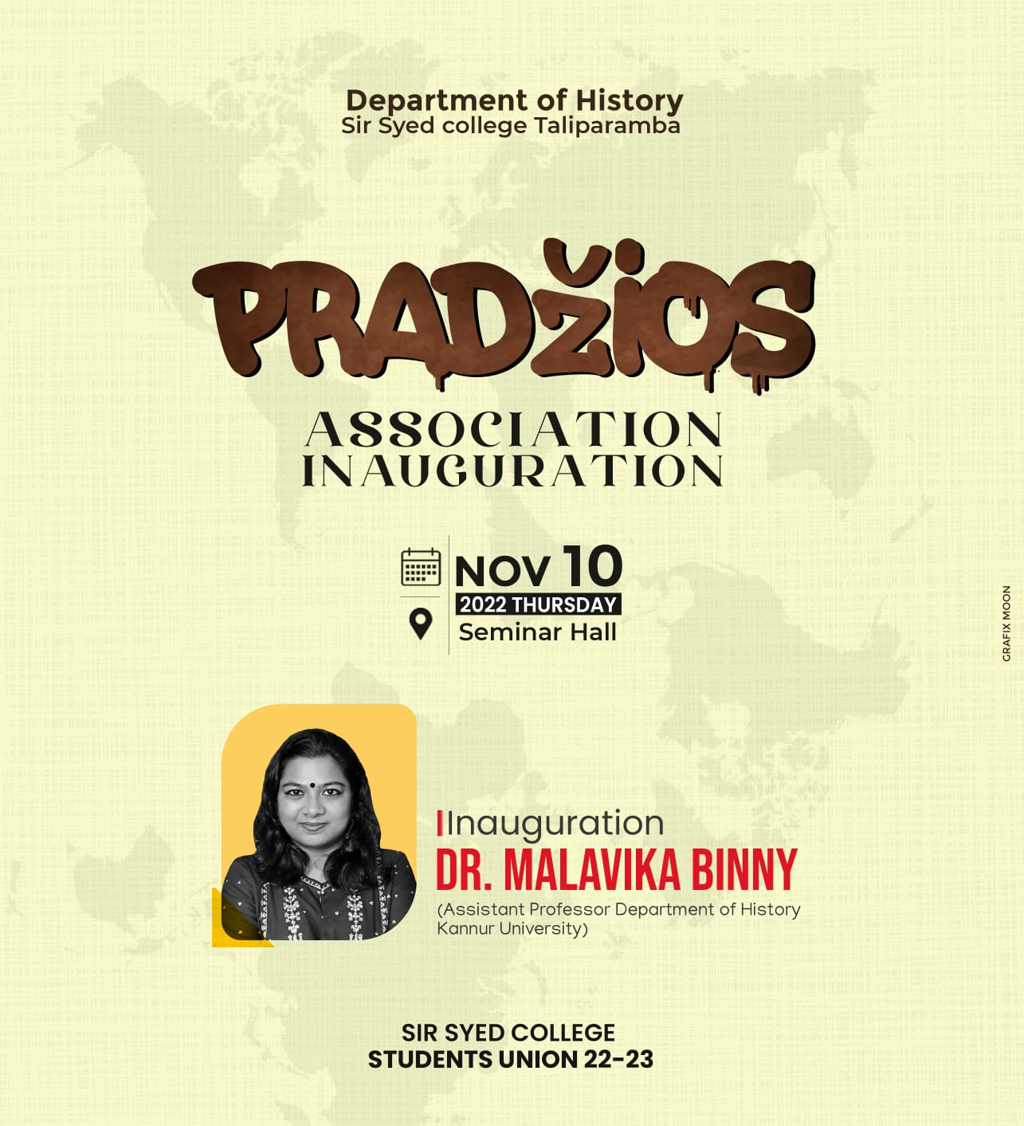
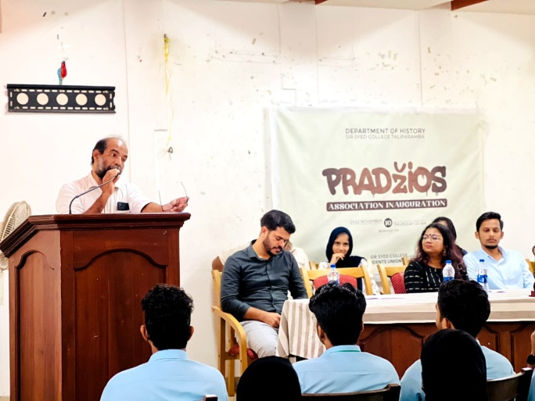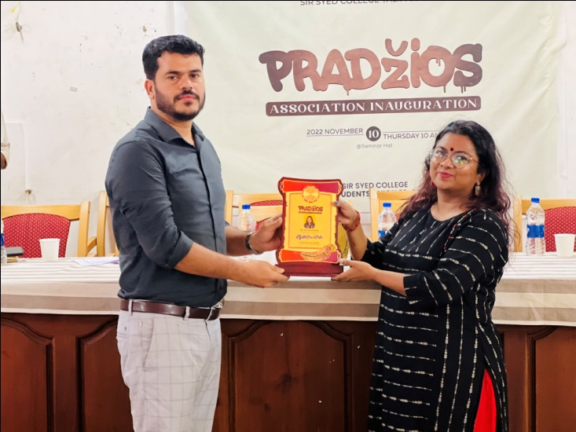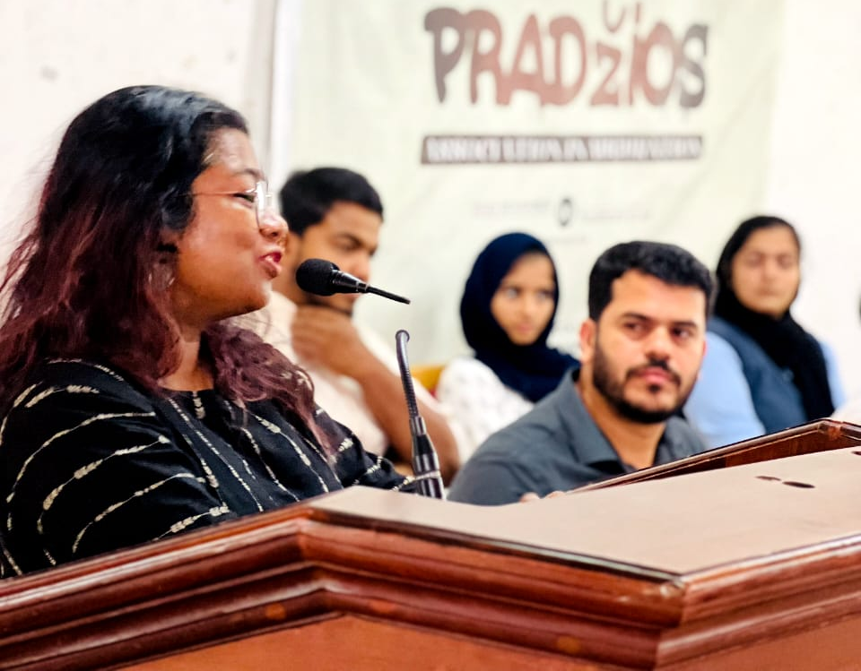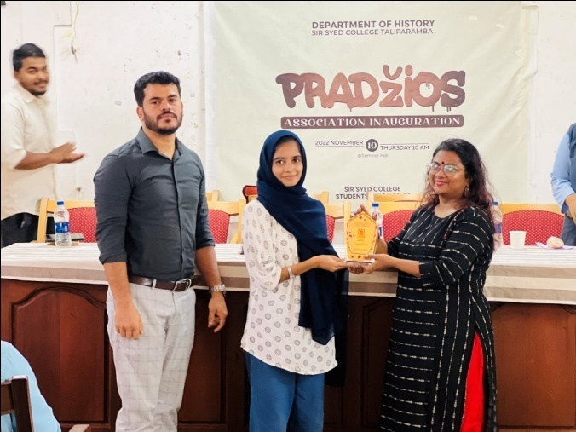

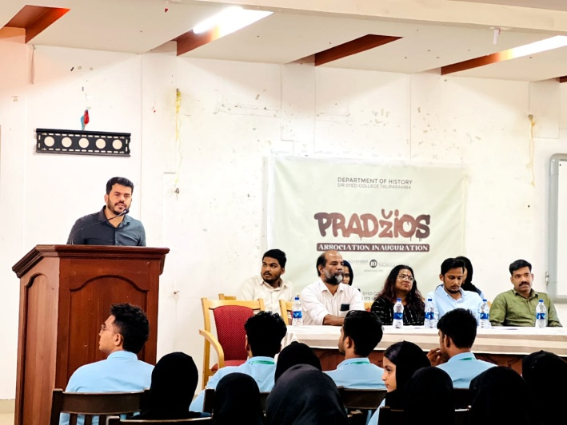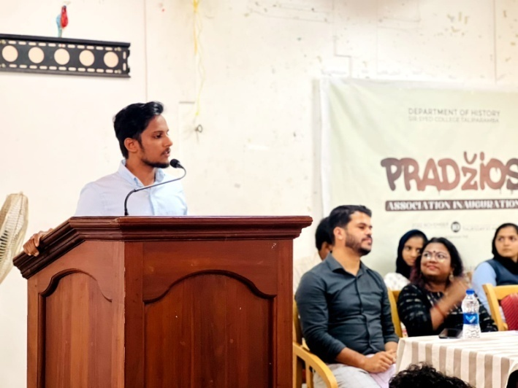
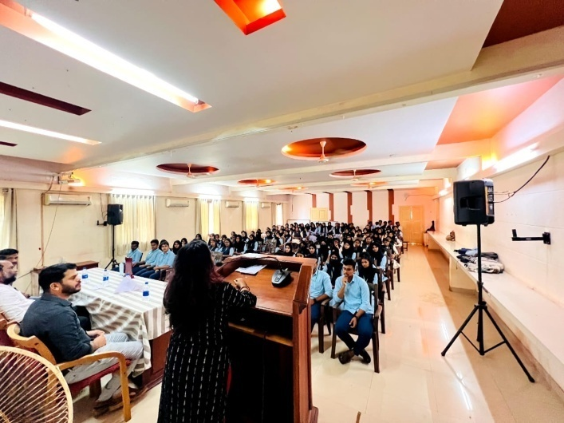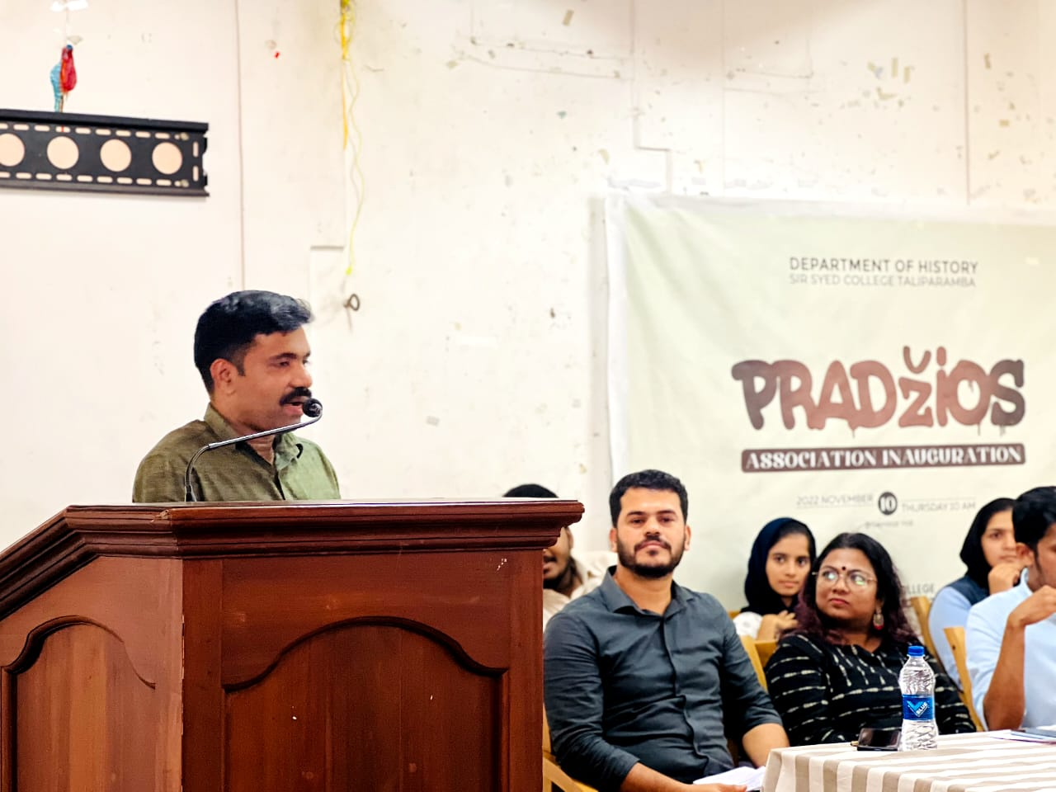
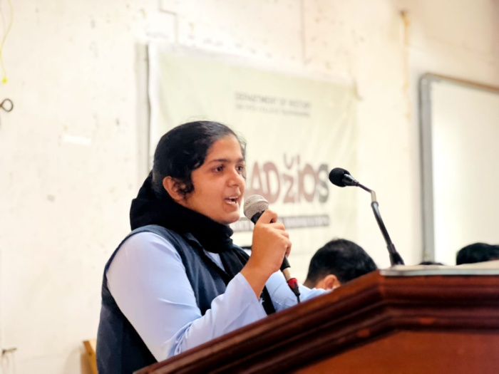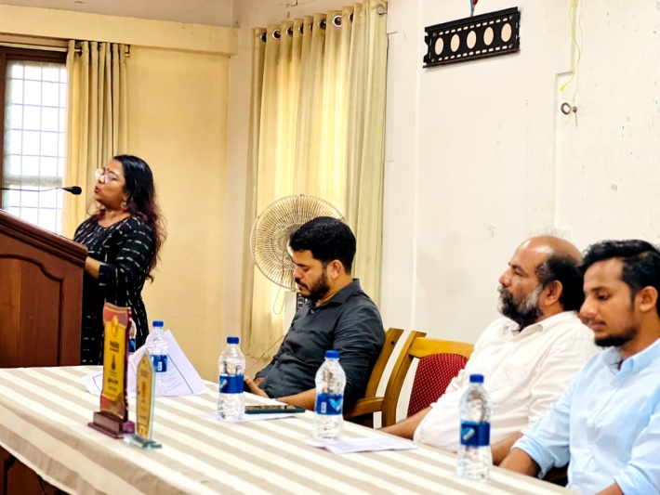
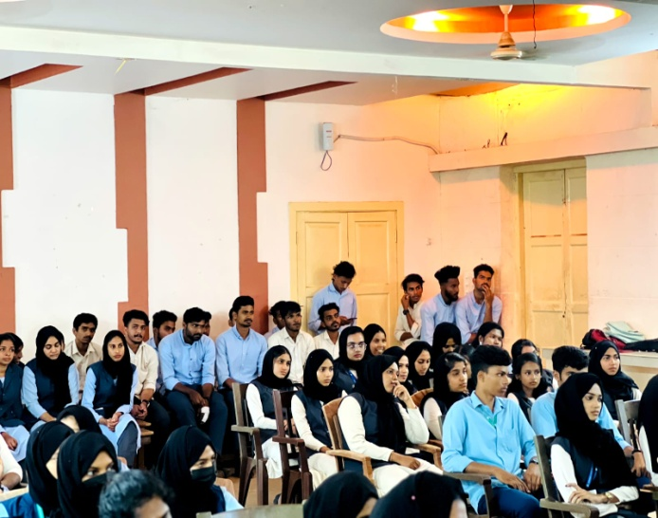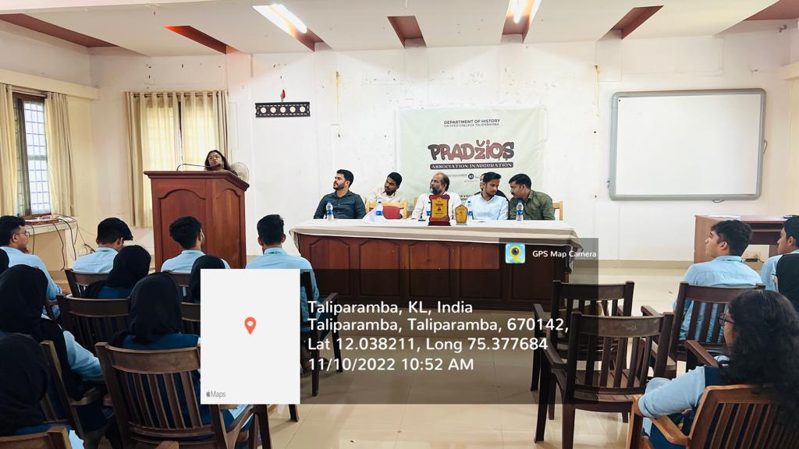

- SUHANA SAFAR - STUDY TOUR

Department of History conducted a Study trip to Historical important sites of Northern India, Delhi, Agra, Kullu and Manali for the sixth semester students as part of Kannur University BA History Curriculum plan. Students along with Department faculties opf Hydarali A , Thwahir PH and Ajeeba, Faculty from Department of English visited various historical sites including, Tajmahal, Redfort, Agra fort, Qutub Minar, Lotus Temple, Delhi Juma Masjid, Solang Valley…etc. it was a 10 days tour from 13th January 2023 to 22nd January 2023. Students and teachers also visited JNU Delhi and made an interaction with the students and faculties of Center for Historical Studies

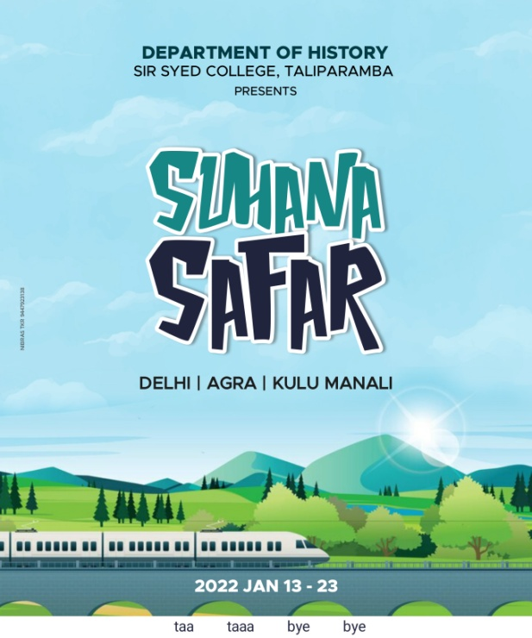. 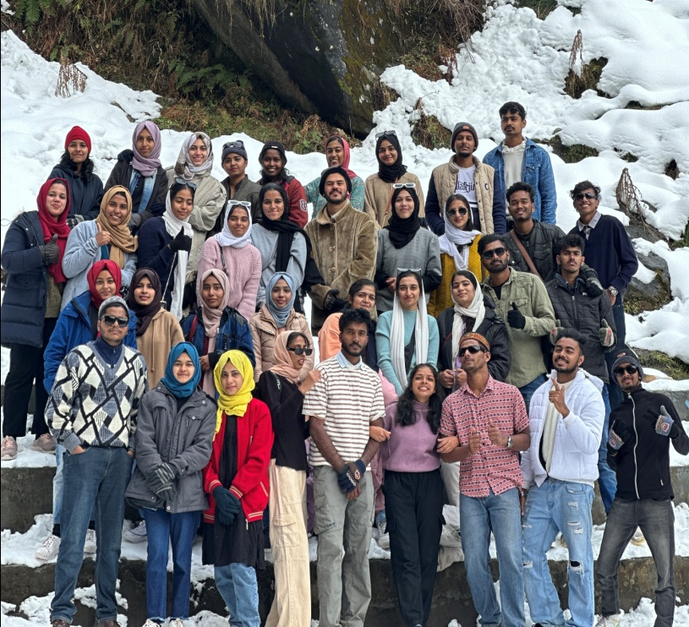

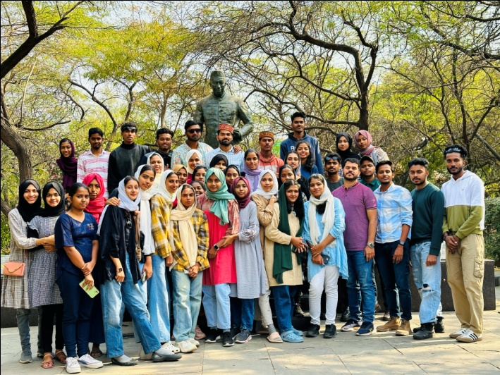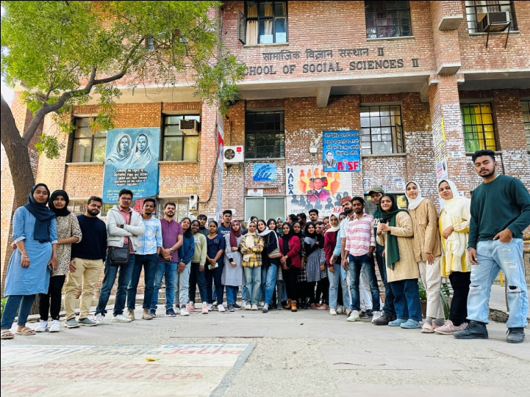

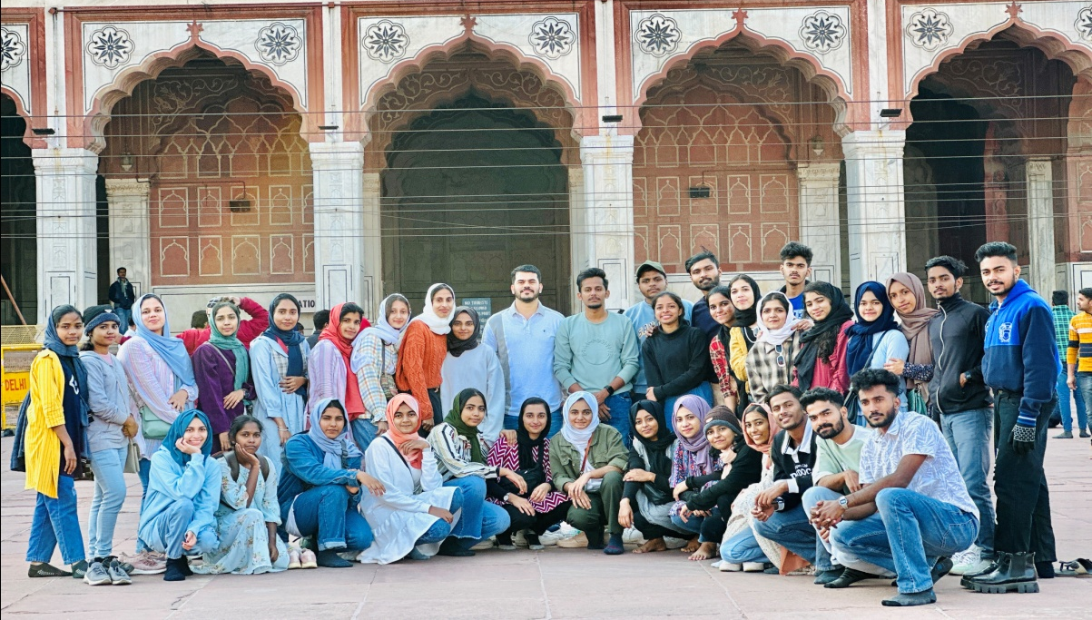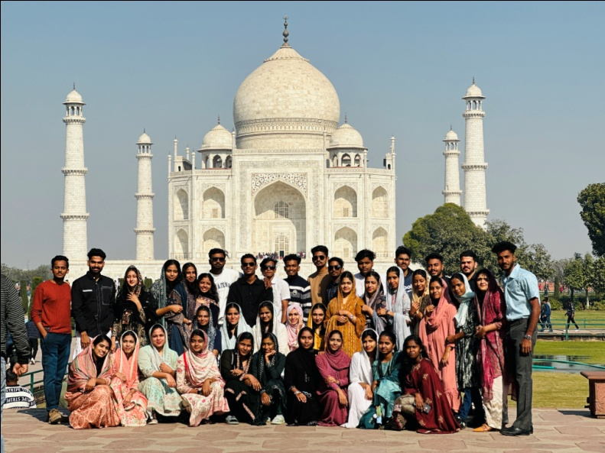
- Excellence meet – 22 February 2023 Wednesday
Department of History and History Association jointly conducted an Excellence meet to honor academic, Sports and Arts achievers of the department students. Hydarali A, Head and Assistant Professor of History delivered welcome speech and It was inaugurated by Dr. Ismail Olayikkara, Principal, Sir Syed College. The program was felicitated by Dr. Sreeja, Coordinator of tutorial system, Mr Shanavas SM, Convener of Academic Committee, Mr. Thwahir PH, Assistant Professor of History and Mr. Ranjith MV, Assistant Professor of History. Principal distributed excellence awards for the qualified students. Fathimath Hanna KT, Association Secretary of History delivered vote of thanks.

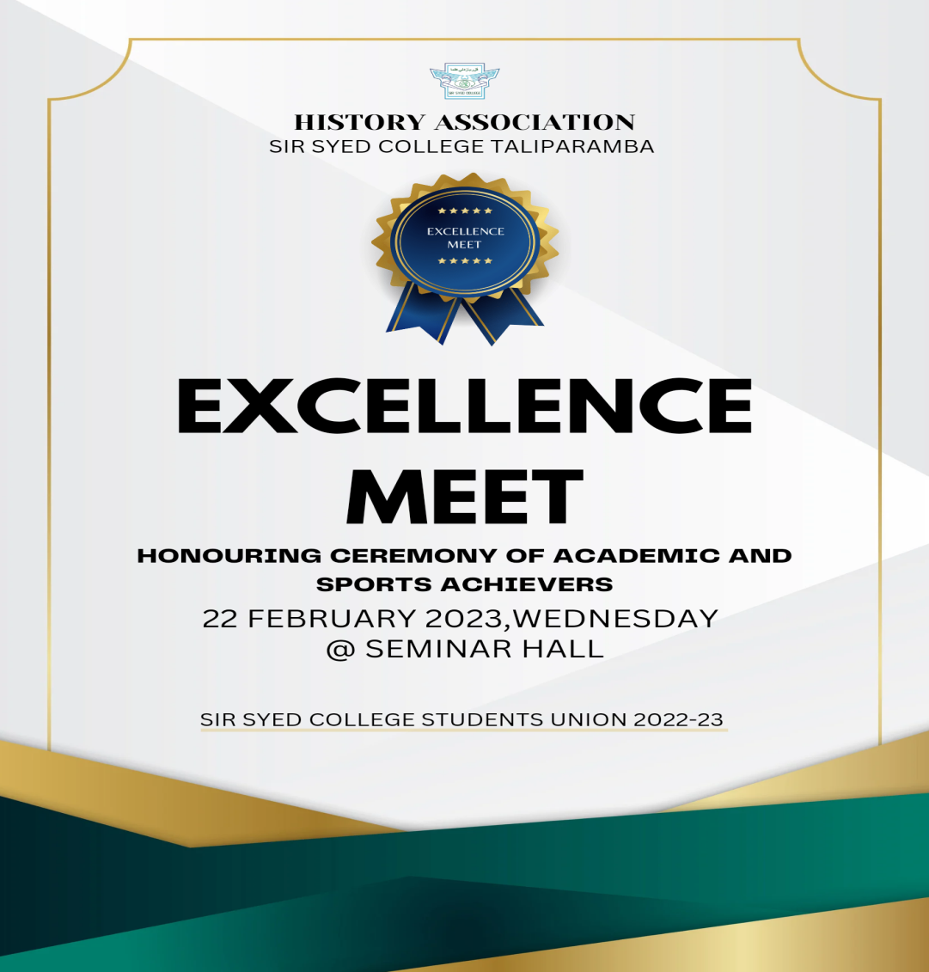
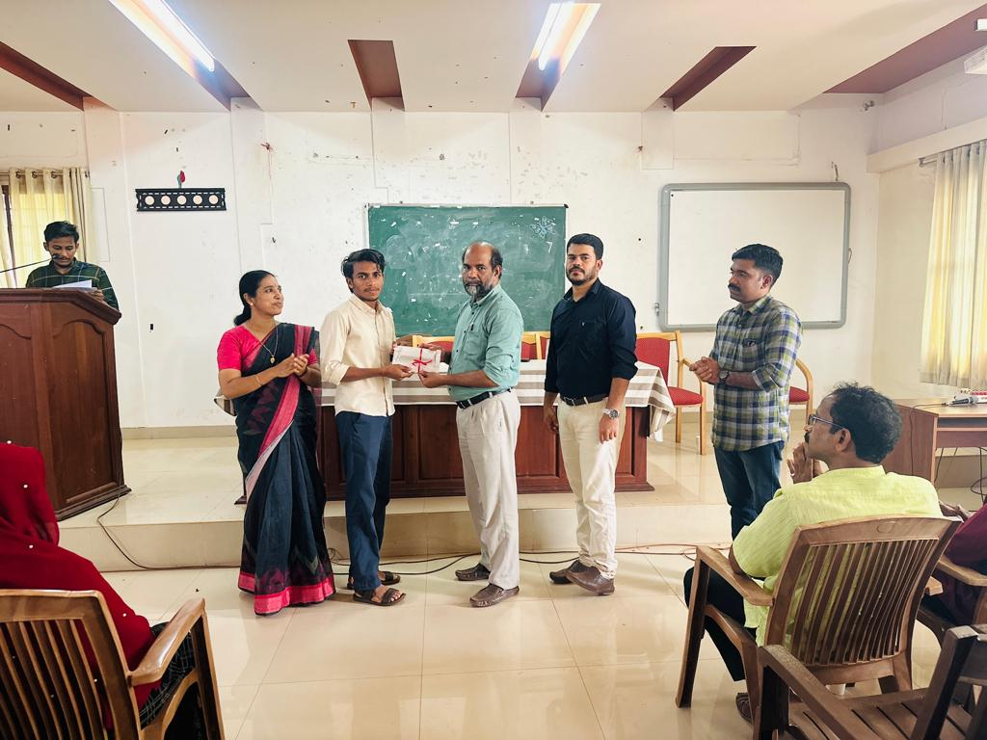
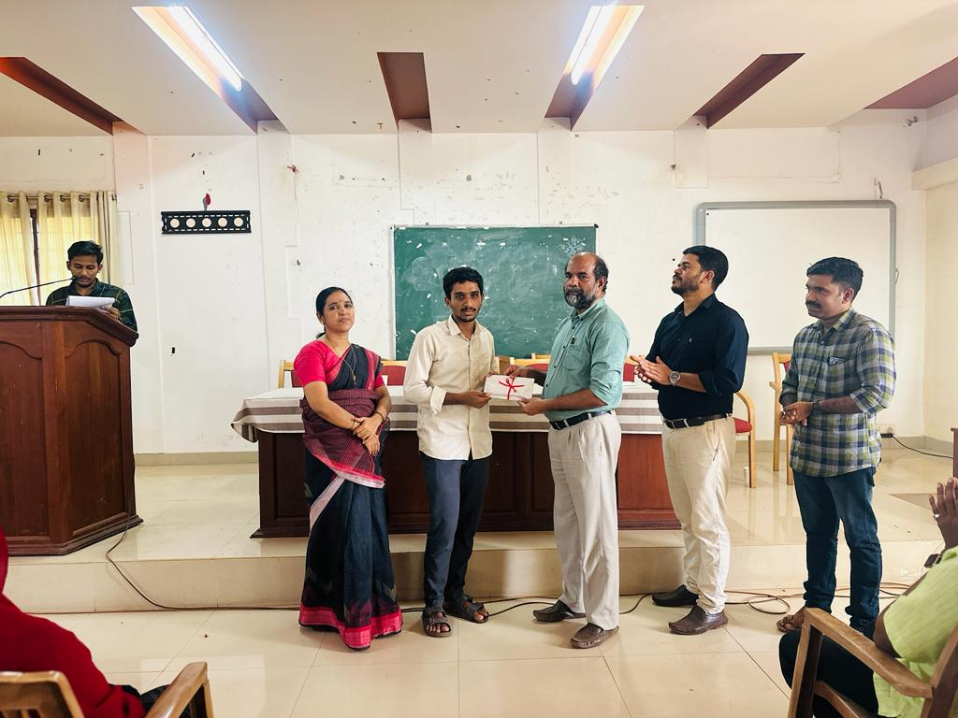

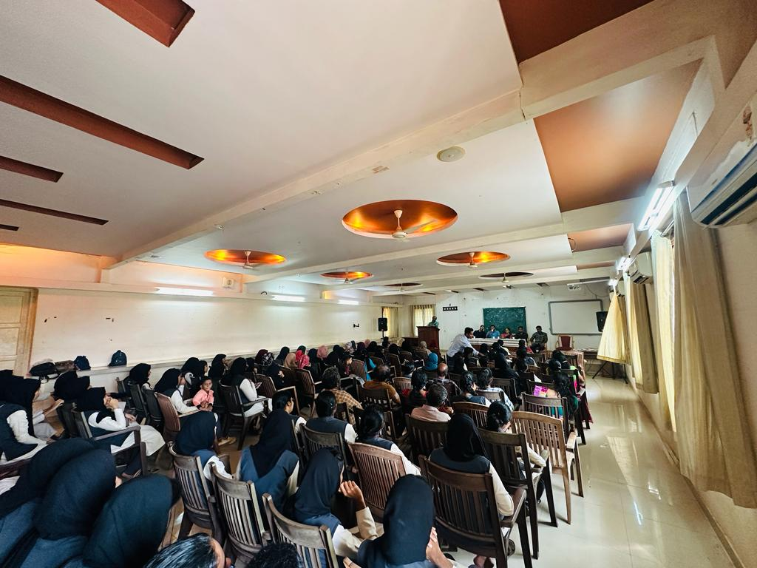

STUDENTS ACHIEVEMENTS

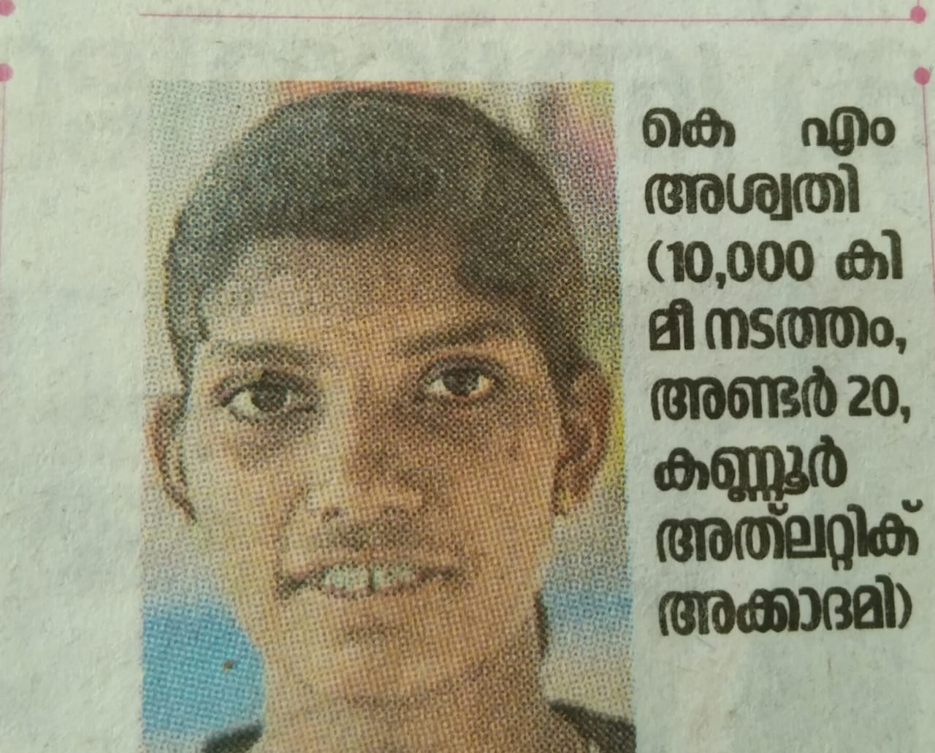
Aswathi K M from fourth semester BA History awarded Gold Medal in 5 KM Walking in Kannur University Athletic Meet
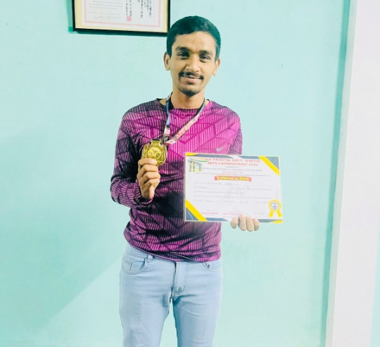
Shajil Sheikh from fourth semester History won Gold medal in second open National all style Martial art championship (Karate)

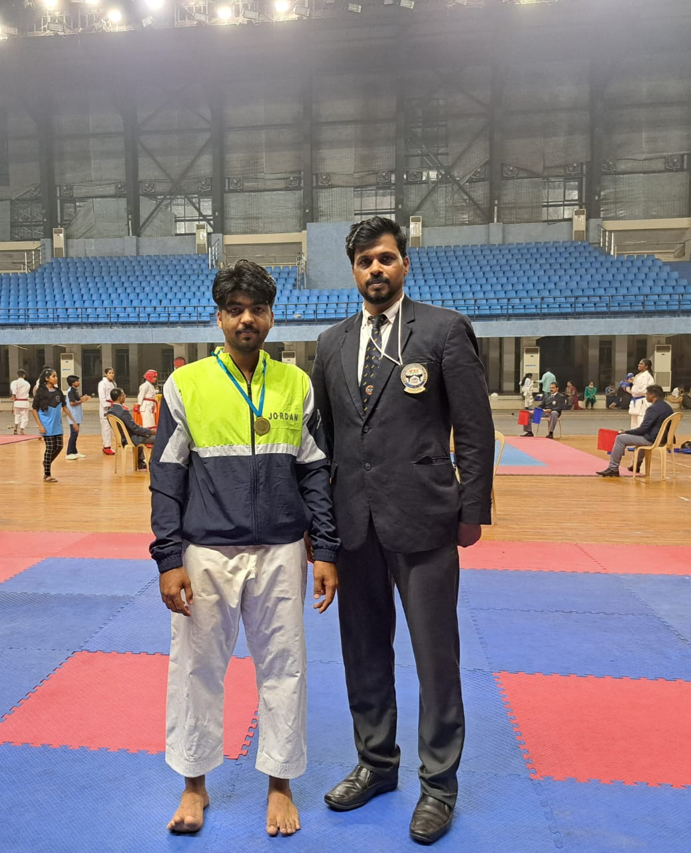
Muhammed Rahil of first semester BA History won Gold Medal in Kannur University Karate Championship (men)

Muhammed Rizan T K from Sixth Semester History won second prize in Kannur University Students Union Arts Festival held at Govt Brennen College, Thalassery for Mappilappattu

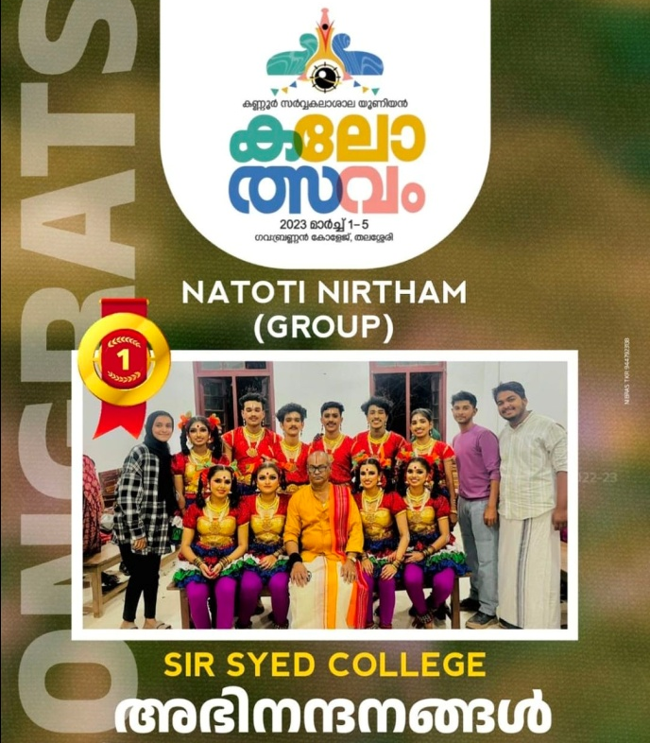

Adithya Rajeesh from Sixth Semester History and team won first prize in Kannur University Students Union Arts Festival held at Govt Brennen College, Thalassery for group dance

