DEPARTMENT OF HISTORY
DEPARTMENT LEVEL ACTIVITIES DURING 2020- 2021

Month and Date | Name of Programme | Theme/Topic/Activity
03, June 2020 - Wednesday | International Webinar Series – DOCTRINA 15 | Multi – Culturalism and interfaith literacy: Challenging the idea of Clash of Civilizations
15 -01-2021  Friday | Orientation Programme | Orientation programme for first year BA History students
10-04-2021 | Study trip to Cochin | Sixth semester history students visited Cochin – Jewish Synagogue, Dutch fort, Fort Cochin ..etc

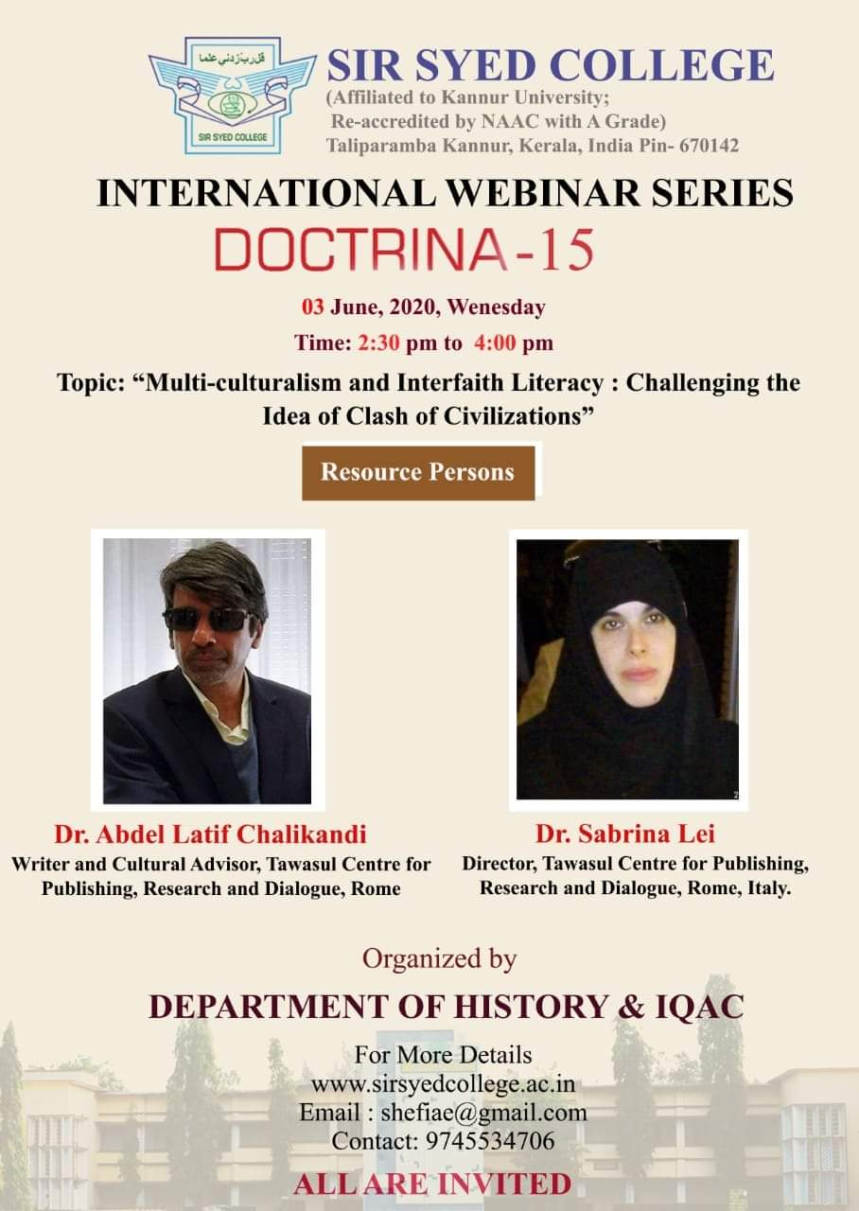
International Webinar

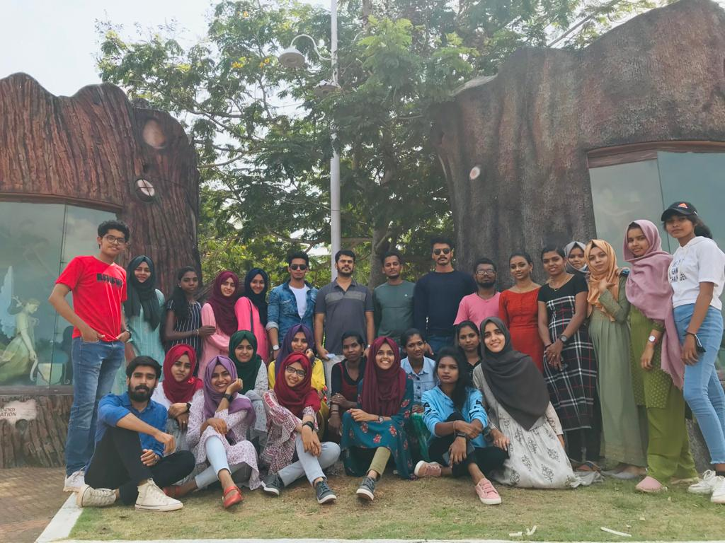
Study trip to Cochin

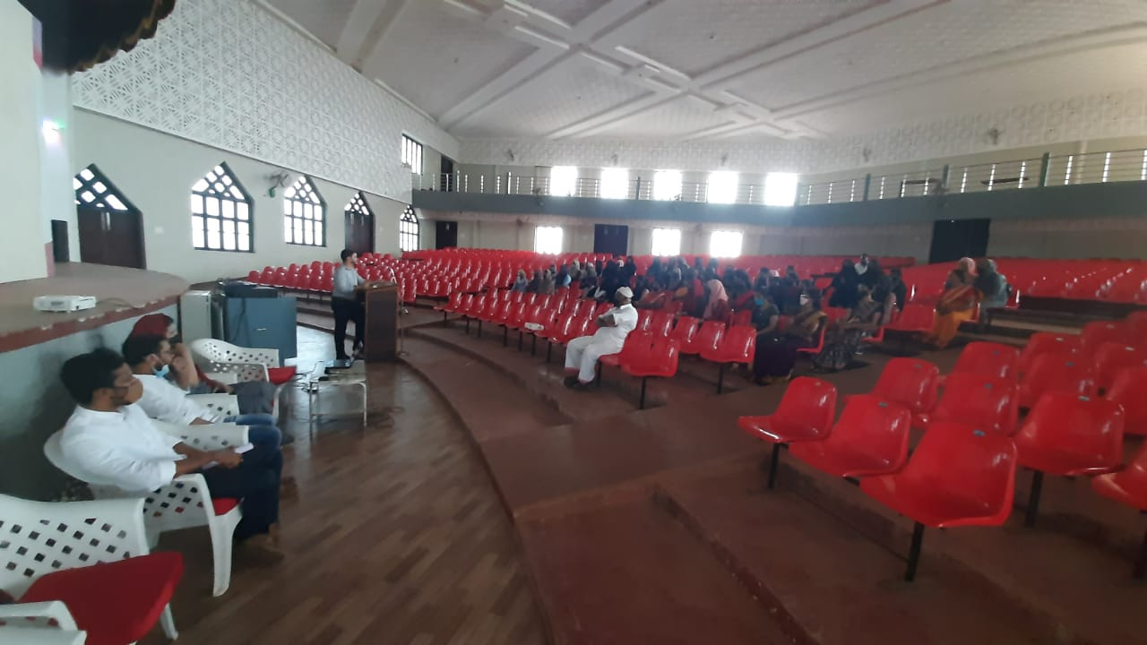
Orientation for first semester BA Students

