DEPARTMENT OF HISTORY
DEPARTMENT LEVEL ACTIVITIES DURING 2019- 2020

Month and Date | Name of Programme | Theme/Topic/Activity
15-17 November 2019 | 7th International Kerala History conference -2019 | International Kerala History conference
03-10-2019 | Speech and Quiz Competitions | Relevance of Gandhian Ideology in the contemporary Indian Society
05-11-2019 | Sir syed Day 2019 | Inaugurated by Sri T K Ratnakumar (DSP Taliparamba). Memorial Lecture by Prof. Dr. A Nujum, Professor AMU
6-01-2020 | Inauguration of History Association | Chief Guest – Dr. Radhamani C P (Asst.Professor and Head of History, PRNSS College, Mattannur
14-01-2020 | Historical site visit | Students from history department Visited Bekal fort, Kasargod.
16 to 19 February 2020 | ‘Chalo Pondi’ – trip to Pondicherry and Chennai | Fourth semester students visited Pondicherry University, Mahabalipuram and Chennai

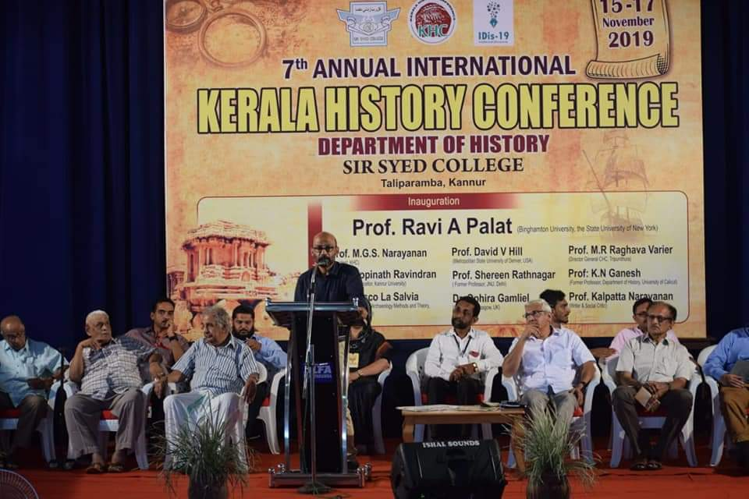

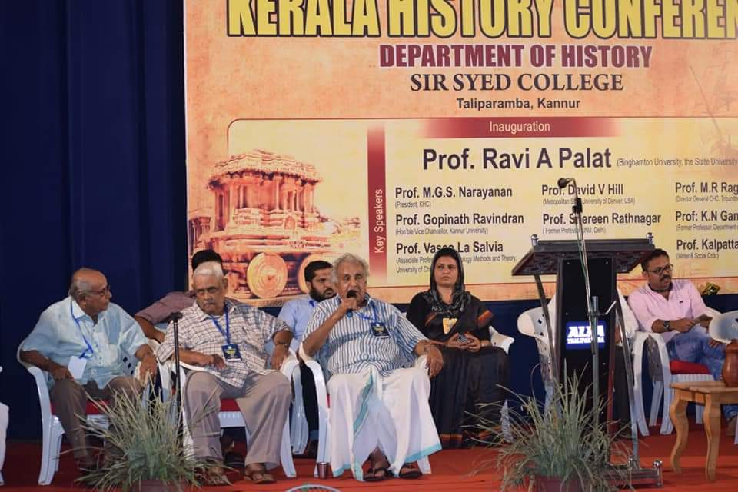

Kerala History Conference - 2019

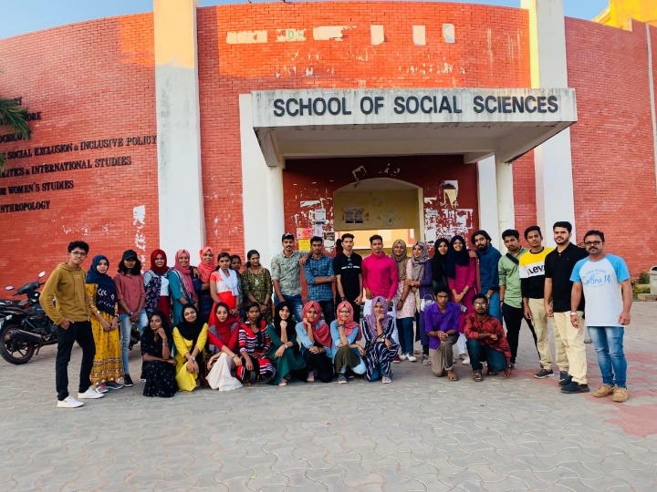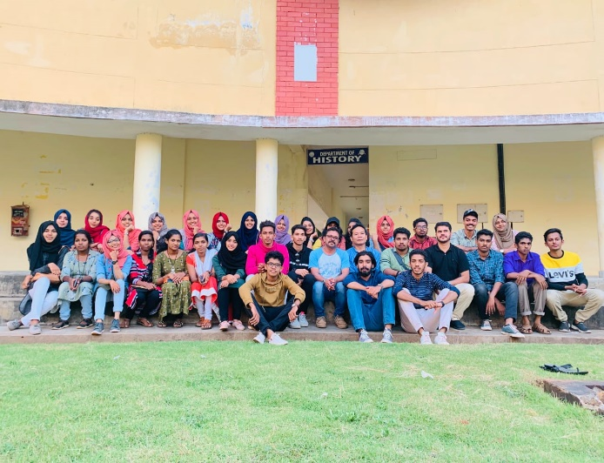
Trip to Pondicherry and Chennai

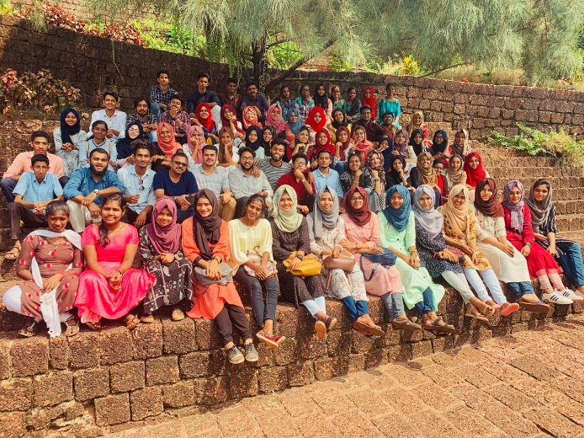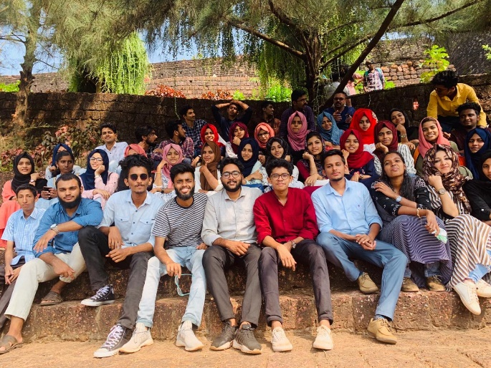
Historical Visit to Bekal Fort, Kasargod
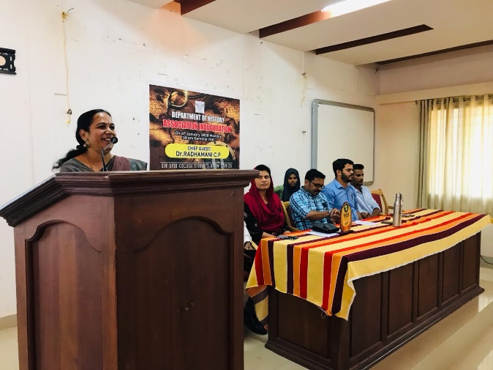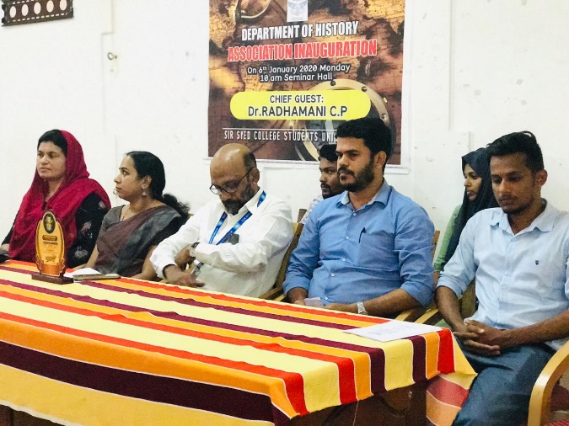
Inauguration of History Association
