**PERSONAL PROFILE**

**P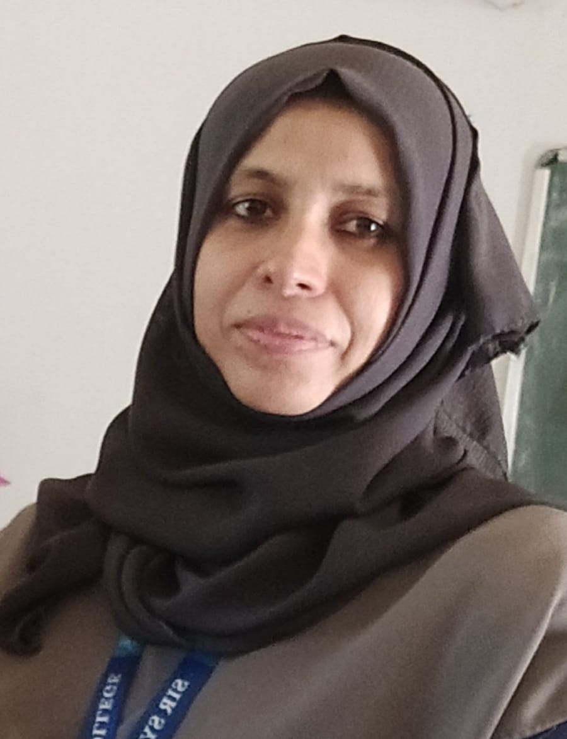hoto**

**(**to be taken by Website Photographer**)**

**KHAIRUNNISA.NP , Ishrath Mehal,**

**Assistant Professor, Railway Station Road,**

**Department of Urdu, Thalassery-4**

**Sir Syed College, Kannur, Kerala, India**

**Taliparamba. Pin Code: 670104**

Name : **KHAIRUNNISA.N.P**

**M.A, Mphil, B.Ed, D.L.Ed, SET, NET**

Gender : Female

Marital Status : Married

Nationality : Indian

Religion : Islam

Phone No :9188385200

E-mail : khairunnisanp@sirsyedcollege.ac.in

Languages Known : Malayalam,English,Hindi,Urdu,Kannada

**Title of Mphil**

Critical Study of Qurrathul Ain Hyder’s Novel Chandni Begum

**Book Published: Sir Syed Ahammed Khan & Urdu Literature**

**(Proceedings of International Webinar-Doctrina16)**

**Education**

|  |  |  |  |
| --- | --- | --- | --- |
| Course | Institution | Year | Specialization |
| M phil | Sree Sankaracharya University of Sanskrit,Regional Centre,Koyilandy | 2009 | Qurathul ain Haider ki Novel Chandni Begum |
| NET |  | 2008 |  |
| M.A | University Of Mysore,Manasagangothri | 2002 | Urdu |
| B.Ed | Keyi Sahib Training College,Karimbam | 2003 | Social Studies |
| D L..Ed | GTTI,Nadakkavu | 2012 | Urdu |
| B.A | Govt.Brennen College,Dharmadam,Thalassery | 2000 | Urdu& Islamic History |
| SET |  | 2005 |  |

**Experience**

|  |  |  |  |
| --- | --- | --- | --- |
| **Institution** | **Designation** | **From** | **To** |
| Sir Syed College,Taliparamb | Assistant Professor | 01.02.2017  Onwards | - |
| Govt.Brennen College,Dharmadam. | Assistant Professor on contract | 5.6.2006 | 20.2.2007 |
| Govt.Brennen College,Dharmadam | Assistant Professor on contract | 10.7.2009 | 31.3.2010 |
| Govt.Brennen College,Dharmadam | Assistant Professor on contract | 9.7.2010 | 10.12.2020 |
| Govt.Brennen College,Dharmadam | Assistant Professor on contract | 1.7.2013 | 31.3.2014 |
| Govt.Brennen College,Dharmadam | Assistant Professor on contract | 2.7.2014 | 31.3.2015 |
| Govt.Brennen College,Dharmadam | Assistant Professor on contract | 22.6.2015 | 31.3.2016 |
| Govt.Brennen College,Dharmadam | Assistant Professor on contract | 20.6.2016 | 20.12.2016 |

**Online Courses Completed**

|  |  |
| --- | --- |
| **Course** | **Institution** |
| **Urdu Script Learning** | **National Council for Promotion of urdu Language, Delhi** |
| **Build Professional e Portfolio in E nglish** | **Georgia Institute of Technology** |
| **Speak English Professionally** | **Georgia Institute of Technology** |

**Articles Published**: National 3 (UGC Care listed )

**Webinar**

**International:** Paper Presentation 2, Participation 4

**National:** Participation 1

**State:** Participation 1

Local **:** Resource Person 1

**National Seminar:** Chair 2 ,Paper Presentation 5,Participation 8

**Workshop:** Resource Person 1 ,Participation 3

**FDP:** Participation 1

**Orientation Programme:** Participation 1

**Refresher Courses** :Participation 1

Seminar/Webinar/ Workshop/ FDP/ Conference Organized:

**International Webinar** : 1

**National Seminar** : 1

**National workshop** :1

**Key Positions / Administrative Duties**

|  |  |  |
| --- | --- | --- |
| **Role** | **Institution/ Committee** | **Year** |
| **Chairperson**  Board of Studies Urdu (Combined) | Kannur University | 2018 |
| **Chairperson**  Board of Studies Urdu UG | Kannur University | 2021 |
| **Member**  Board of Studies Urdu & Persian UG Calicut University | Calicut University | 2023 |
| **Chair Person**  Board of Question Paper Setting Adeeb e Fazil Priliminary | Calicut University | 2022&2023 |
| **Member**  Board of Question Paper Setting Adeeb e Fazil Final | Calicut University | 2022 &2023 |
| **Member**  Confidential work of SCERT | SCERT,Thiruvanathapuram | 2019  onwards |
| **Member**  Confidential work of Kerala P Sc | Kerala Public Service Commission | 2022  onwards |
| **Advisory Board Member**  UGC Care listed Journal Adabee Zaviye | UGC Carelisted Journal,Uthar Pradesh | 2023 onwards |
| **Academic Counsellor of Urdu** | IGNOU ,Kannur Study Centre | 2016 onwards |
| **Member**  Anti Hijack Committee | International Air Port, Kannur | 2018  onwards |
| **Co-ordinator**  Jeevani Counselling for Students well being | Sir Syed College | 2023 |
| **Head of the Department of Urdu** | Sir Syed College | 2017 onwards |
| **Member of College Council** | Sir Syed College | 2017 onwards |
| **Co-ordinator**  DQAC,Urdu | Sir Syed College | 2017 onwards |
| **Representative of Faculty Members**  Anti Ragging Committee | Sir Syed College | 2017,2018 |
| **Convenor**  Model Examination Committee | Sir Syed College | 2023 |
| **Covenor**  Talent Scan | Sir Syed College | 2017,2018 |
| **Convenor**  Clean the Campus Forum | Sir Syed College | 2018,2019 |
| **Convenor**  Value Education Committee | Sir Syed College | 2019,2020 |
| **Co-ordinator of Moodle**  Department of Urdu | Sir Syed College | 2020,2021,2022 |
| **Co-ordinator of College website**  Department of Urdu | Sir Syed College | 2020,2021,2022 |
| **Covenor**  Add on Course | Sir Syed College | 2021,2022,2023 |
| **Co-ordinator**  Add on Course Urdu | Sir Syed College | 2022 |
| **Convenor**  Urdu Club | Sir Syed College | 2017  Onwards |
| **Class Tutor**  3 rd & 4th Sem B A Economics | Sir Syed College | 2021,2022 |
|  |  |  |
|  |  |  |
|  |  |  |
|  |  |  |
|  |  |  |
|  |  |  |
|  |  |  |
|  |  |  |
|  |  |  |
|  |  |  |
|  |  |  |
|  |  |  |

I hereby declare that above mentioned information are true to the best of my knowledge and belief.

Taliparamba

01/12/2023 **KHAIRUNNISA.NP**